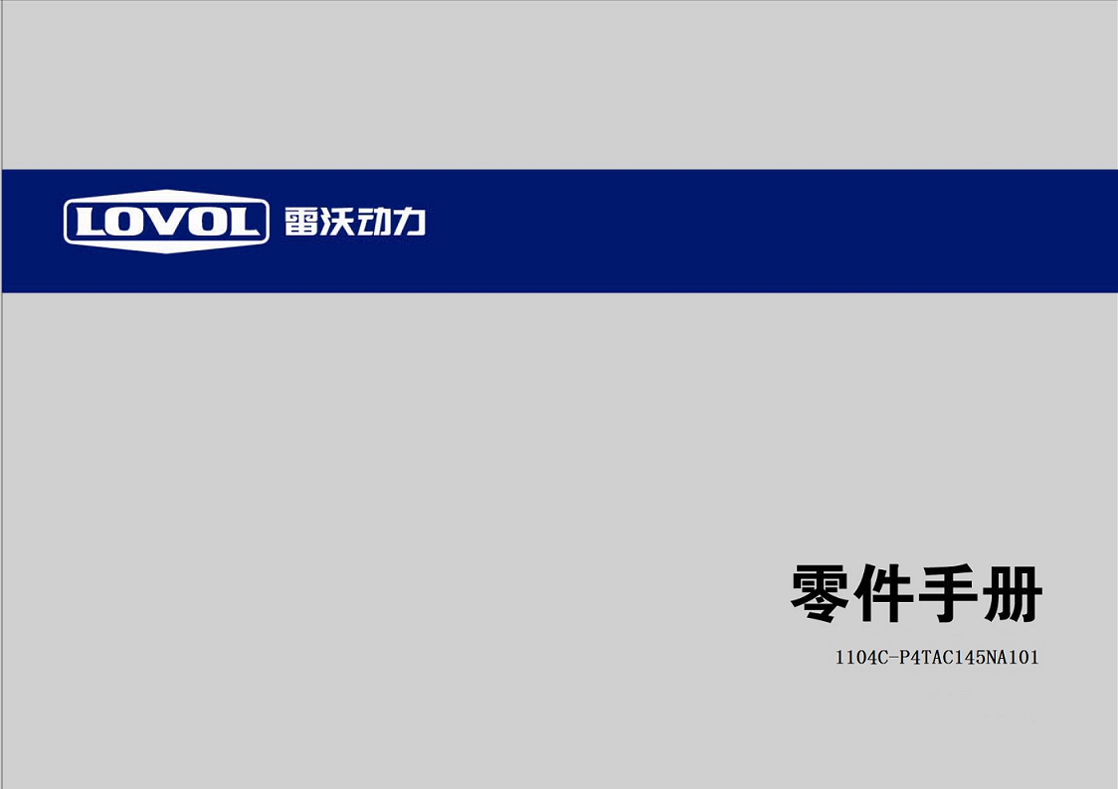

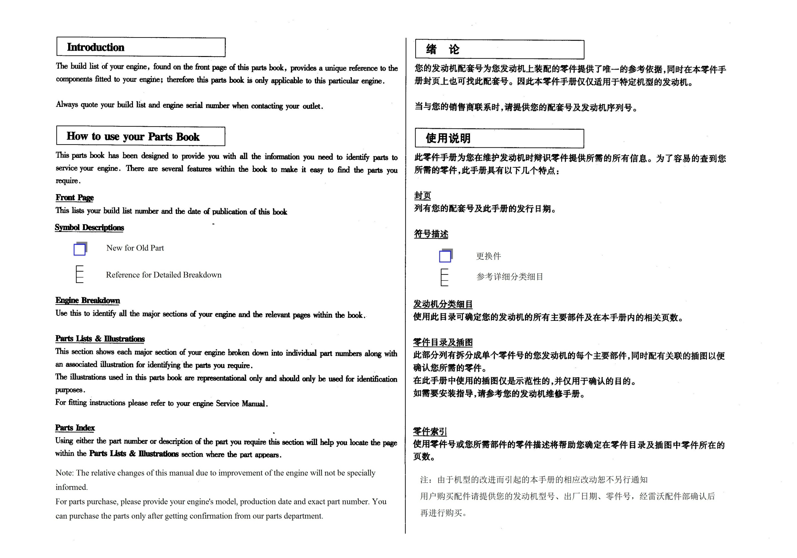

Section 部件
Cylinder Block 气缸体 | 1
ACHA
Timing Gear& Camshaft 正时齿轮及凸轮轴 | 2
ACHA
Crankshaft, Pistons & Connecting Rods 曲轴，活塞及连杆 | 4
ACHA
Cylinder Head 气缸盖 | 5
ACHA
Rocker shaft摇臂轴 | 6
ACHA
Lubricating Oil Pump 润滑油泵 | 7
ACHA
Fuel Injection Equipment 燃油喷射系统 | 8
AFHA
Flywheel Hosing 飞轮壳 | 9
CDHA
Flywheel & Starter Ring 飞轮及启动齿圈 | 10
DDHA
Starter motor 启动马达 | 11
ED
Fan Drive 风扇驱动装置 | 12
FBH00001
Lubricating Oil Sump 润滑油底壳 | 13
GBHA
Cover Plate& Filler 盖板及加油口 | 14
HBHA
Cylinder Head Cover 气缸盖罩 | 15
HBHA
Lub. oil Filter 机油滤清器 | 16
VBHA
Front End Drive Input 前端驱动输入 | 17
KBHA

Engine Breakdown 发动机分类细目
Section 部件
Water Pump & Thermostat 水泵及节温器 | 18
LBHA
Water Outlet 水出口 | 20
LDHA
Fan Drive 风扇驱动装置 | 21
FBHA
Alternator & Generator 交流发电机及发电机 | 22
NDHA
Gear Drive Auxiliary Drive Option 齿轮驱动/转向助力选用 | 23
QDHA
Induction & Exhaust System 进、排气系统 | 24
SBHA
Low Pressure Fuel Oil System 低压燃油系统 | 27
VBHA
Engine Lifting 发动机提升 | 29
WDHA
Throttle & Stop Controls 油门及停车控制 | 30
ZAHA
Mountings 支撑 | 31
ZCHA
Lub.Oil Pressure Switch & Gauge 润滑油压开关及油压表 | 32
ZJHA
Silencer消音器 | 33
ZUHA
Joints & Gaskets-Top Service Kit 垫及垫片 | 34
SACA
Joints & Gaskets- Bottom Service Kit 垫及垫片 | 35
SACA
A set with four segments四配套 | 36

Cylinder Block 气缸体 ACHA

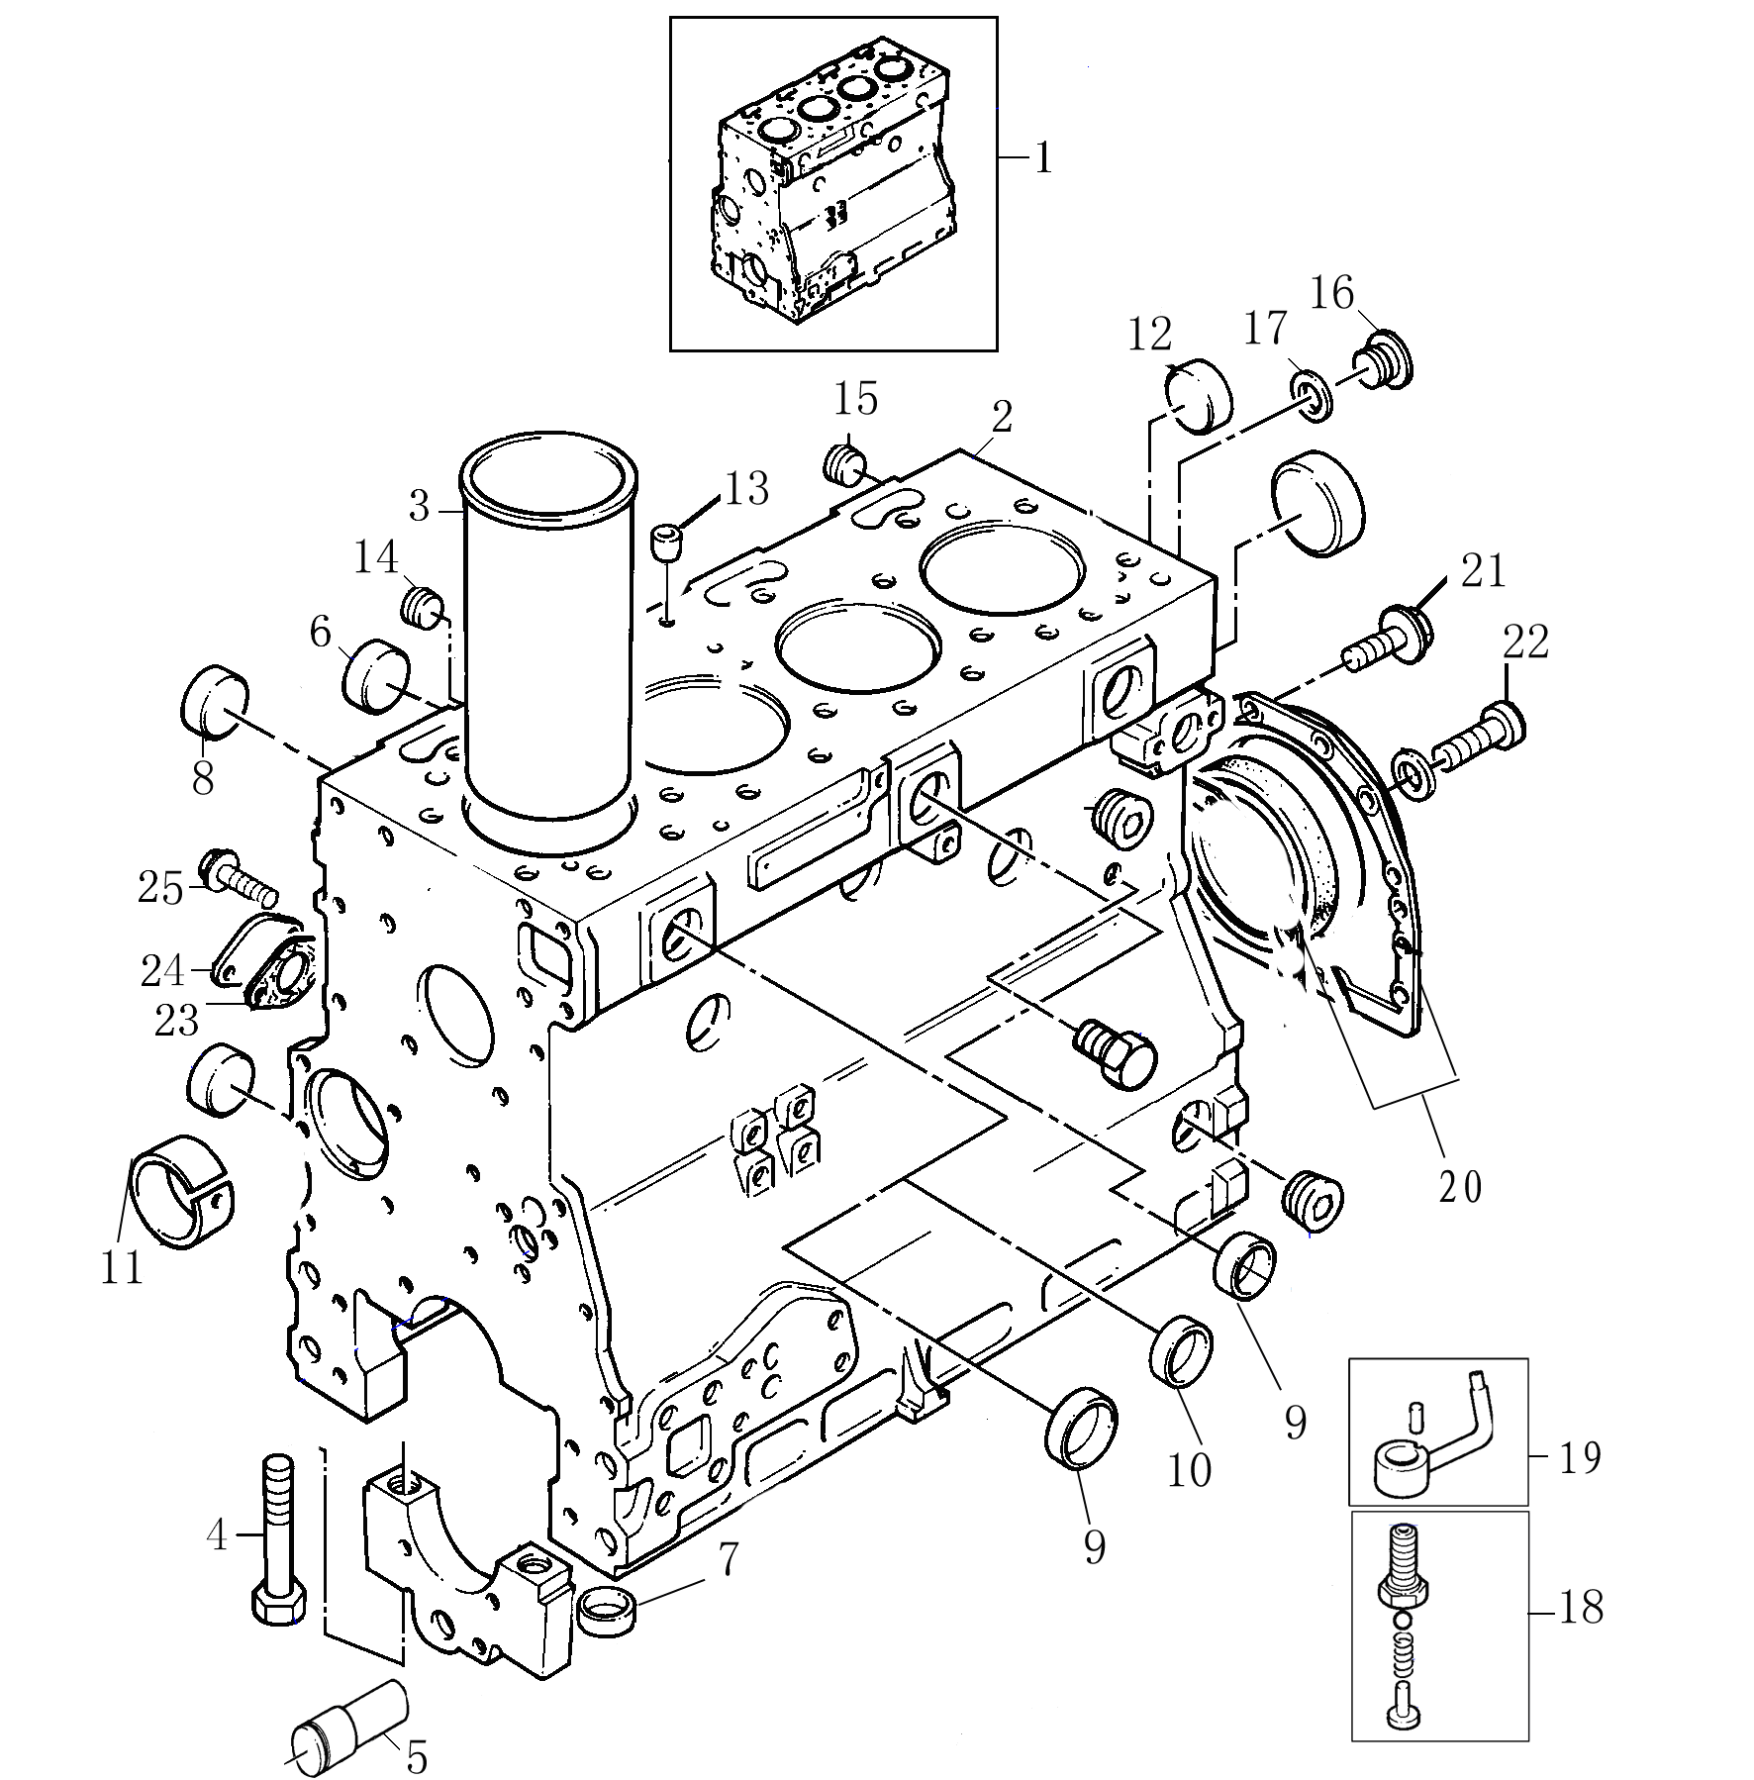
Cylinder Block 气缸体 ACHA
Item  图示号 | Family No.  组件号 | Part No.  零件号 | Part Name  零件名称 |  | Qty.  数量
1 | AC10A 0004 | TZZ50265 | 机体（总成） | Cyl. block assy. | 1
2 |  | T721010069 | 机体 | Cylinder block | 1
3 |  | T721020012 | 缸套 | Liner | 4
4 |  | T32166329 | 大瓦螺栓 | Bolt | 10
5 |  | T3271H004A | 惰轮轴 | Idler shaft | 1
6 |  | T3774A004 | 挺杆腔堵 | Plug | 4
7 |  | T33142111 | 定位套 | Thimble | 10
8 |  | T32418122 | 碗堵 | Plug | 6
9 |  | T0650710 | 碗堵 | Plug | 6
10 |  | T32418124 | 碗堵 | Plug | 1
11 | AC10A 0064 | T31134165 | 衬套 | Bush | 1
12 | AC10A 0115 | T32416119 | 堵 | Plug | 1
13 | AC10A 0121 | T32417134 M | 堵 | Plug | 1
14 | AC10A 0124 | T64404002 M | 堵 | Plug | 1
15 | AC10A 0176 | T0650588 | 堵 | Plug | 1
16 | AC10A 0325 | T32168212 | 堵 | Plug | 1
17 | AC10A 0328 | T714030009 | 垫圈 | Washer | 1
18 | AC20L 0500 | T4138A017 | 冷却喷嘴阀 | Valve | 4
19 | AC20L 0456 | T3861A027 | 冷却喷嘴 | Piston cooling jet | 4
20 | AC10A 0373 | T721050003 | 后油封 | Rear oil seal housing | 1
21 | AC10A 0400 | T3211C002 | 螺栓 | Screw | 6
22 | AC10A 0439 | T3211C002 | 螺栓 | Screw | 4

Timing Gear& Camshaft正时齿轮及凸轮轴 ACHA

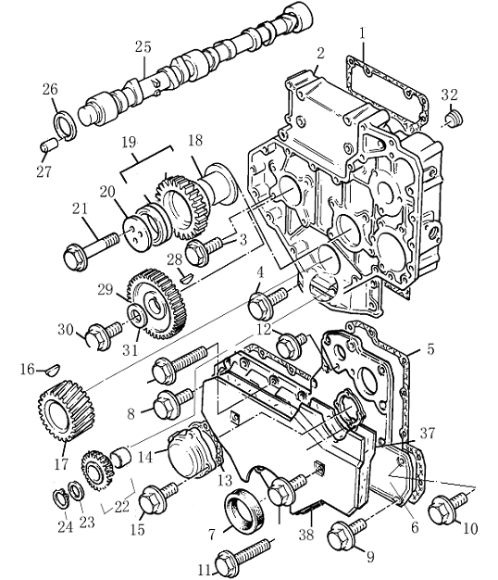
Timing Gear& Camshaft正时齿轮及凸轮轴 ACHA
Item  图示号 | Family No.  组件号 | Part No.  零件号 | Part Name  零件名称 |  | Qty.  数量
1 | AC10B 0001 | T3681P009 | 垫 | Joint | 1
2 | AC10B 0010 | T3716C133A | 正时齿轮室 | Timing case | 1
3 | AC10B 0037 | T2314H003 | 螺栓 | Screw | 8
4 | AC10B 0040 | T2314H034 | 螺栓 | Screw | 4
5 | AC10B 0274 | T3681P034 | 前盖垫 | Joint | 1
6 | AC10B 0277 | T3716M091B | 前盖 | Front cover | 1
7 | AC10B 0278 | T2418F436 | 油封 | Seal | 1
8 | AC10B 0316 | T2314H005 | 螺栓 | Screw | 8
9 | AC10B 0320 | T2314H004 | 螺栓 | Screw | 1
10 | AC10B 0325 | T2314H034 | 螺栓 | Screw | 1
11 | AC10B 0350 | T2314H034 | 螺栓 | Screw | 2
12 | AC10B 0436 | T2314H013 | 螺栓 | Screw | 7
13 | AC10B 0505 | T3682H003 | 垫 | Joint | 1
14 | AC10B 0508 | T3753R211 | 检查盖 | Inspection cover | 1
15 | AC10B 0511 | T2314F036 | 螺栓 | Screw | 4
16 | AC10J 0004 | T0500012 | 键 | Key | 1
17 | AC10J 0007 | T3117C061 | 齿轮 | Gear | 1
18 | AC10J 0013 | T33426161A | 轮毂 | Hub | 1
19 | AC10J 0031 | T4111A013 | 齿轮 | Gear | 1
20 | AC10J 0054 | T3241H009 | 板 | Plate | 1
21 | AC10J 0069 | T2314J010 | 螺栓 | Screw | 3
22 | AC10J 0129 | T4111A021 | 齿轮 | Gear | 1
23 | AC10J 0144 | T33123125 | 垫圈 | Washer | 1
24 | AC10J 0150 | T2722A206 | 卡簧 | Circlip | 1
25 | AC10J 0180 | T31415364 | 凸轮轴 | Camshaft | 1
26 | AC10J 0183 | T33153121 | 板 | Plate | 1
27 | AC10J 0189 | T2116053 | 销子 | Pin | 1
28 | AC10J 0195 | T0500012 | 键 | Key | 1

Timing Gear& Camshaft正时齿轮及凸轮轴 ACHA

Timing Gear& Camshaft正时齿轮及凸轮轴 ACHA
Item  图示号 | Family No.  组件号 | Part No.  零件号 | Part Name  零件名称 |  | Qty.  数量
29 | AC10J 0201 | T3117L023 | 齿轮 | Gear | 1
30 | AC10J 0207 | T2314J606 | 螺栓 | Screw | 1
31 | AC10J 0214 | T3321A003 | 垫圈 | Washer | 1
32 | AF25B 0002 | T0650586M | 堵 | Plug | 1

Crankshaft Pistons & Connecting Rods曲轴，活塞及连杆 ACHA

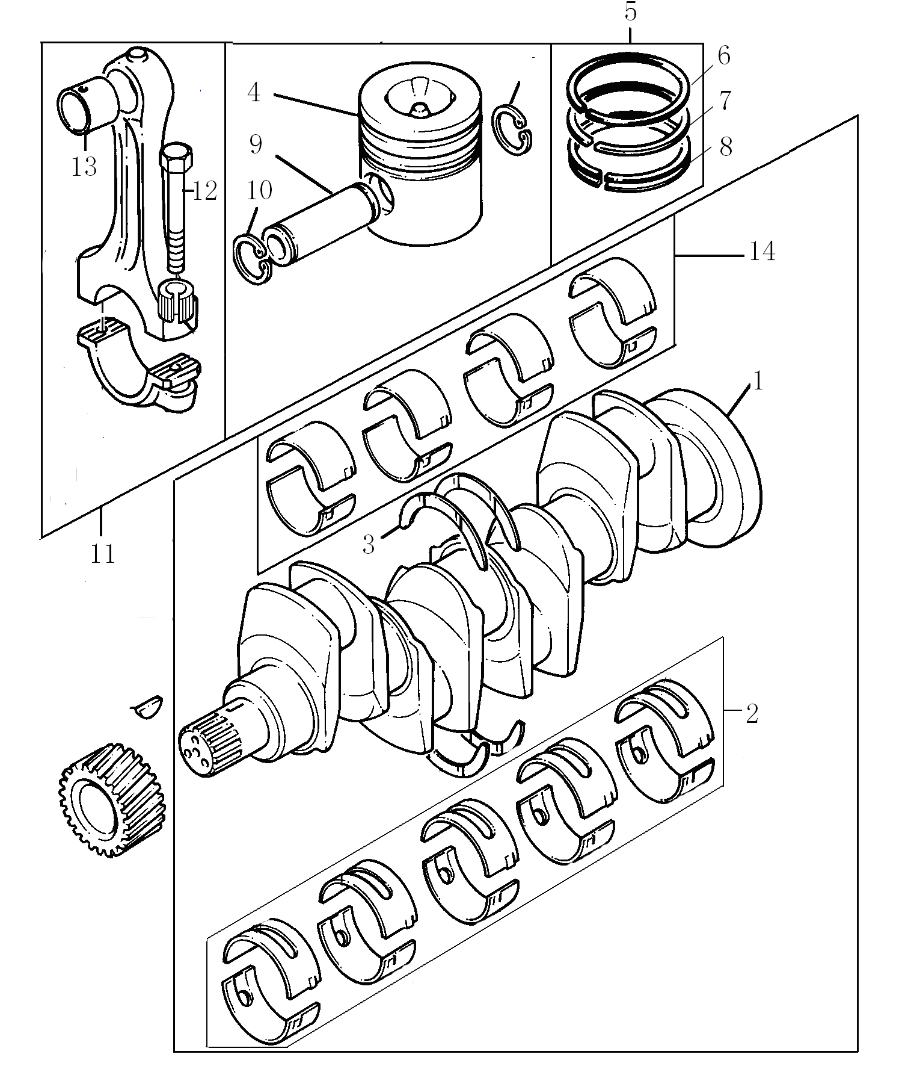
Crankshaft Pistons & Connecting Rods曲轴，活塞及连杆 ACHA
Item  图示号 | Family No.  组件号 | Part No.  零件号 | Part Name  零件名称 |  | Qty.  数量
1 | AC10C 0005 | T31315681 | 曲轴 | Crankshaft | 1
2 |  | T81558 | 主轴瓦 | Bearing assy. | 1
3 |  | TZZ90001 | 止推片总成 | Thrust Washer Assy. | 1
4 | AC10D 0005 | T3135J186A | 活塞 | Piston | 4
5 | AC10D 0008 | T4181A026 | 活塞环 | Ring | 4
6 |  | T3136J051 | 气环 | Compression ring | 1
7 |  | T3136X021 | 气环 | Compression ring | 1
8 |  | T3137N021 | 油环 | Scraper ring | 1
9 | AC10D 0019 | T3313T005 | 活塞销 | Piston pin | 4
10 | AC10D 0022 | T2721332 | 卡簧 | Circlip | 8
11 | AC10D 0028 | T4115C211 | 连杆总成 | Connecting rod assy. | 4
12 |  | T32186142 | 连杆螺栓 | Screw | 2
13 |  | T3112E005 | 小头衬套 | Bush | 1
14 | AC10D 0056 | T31132011 | 轴瓦 | Bearing | 8

Cylinder Head气缸盖 ACHA

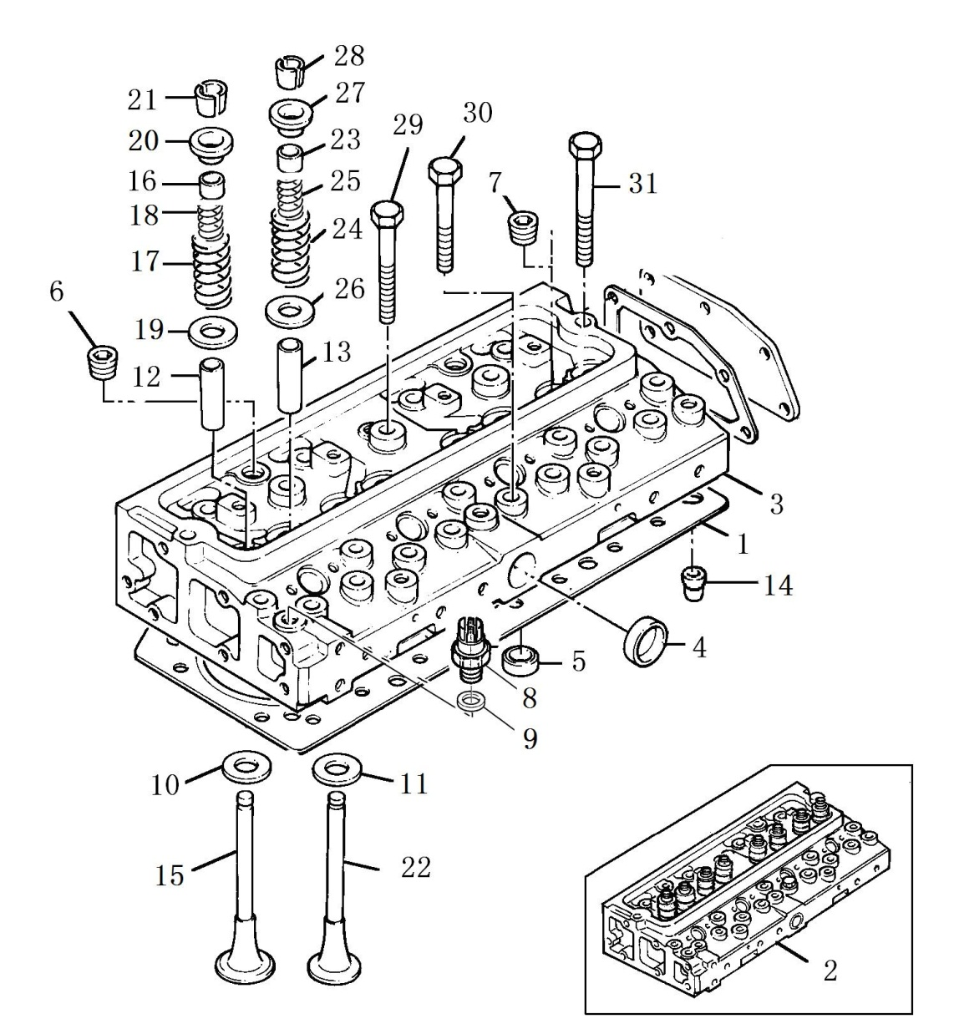
Cylinder Head气缸盖 ACHA
Item  图示号 | Family No.  组件号 | Part No.  零件号 | Part Name  零件名称 |  | Qty.  数量
1 | AC10E 0004 | T3681E033D | 缸盖垫 | Gasket | 1
2 | AC10E 0005 | TZZ80221 | 缸盖（总成） | Cylinder head assy. | 1
3 |  | T3712H074 | 包括：缸盖 | Cylinder head | 1
4 |  | T0650710 | 碗堵 | Plug | 1
5 |  | T32417121 | 出沙孔堵 | Plug | 4
6 |  | T0650586 | 堵 | Plug | 4
7 |  | T3324E003 | 进气阀座 | Inlet insert | 4
8 |  | T3314A122 | 排气阀座 | Exhaust insert | 4
9 | AC10E 0037 | T3343F042A | 进气门导管 | Guide | 4
10 | AC10E 0040 | T3343J022A | 排气门导管 | Guide | 4
11 | AC10E 0064 | T2114A046 | 定位销 | Thimble | 2
12 | AC10F 0001 | T3142L072 | 进气门 | Inlet valve | 4
13 | AC10F 0004 | T33817117B | 密封圈 | Seal | 4
14 | AC10F 0007 | T31745122 | 外弹簧 | Spring | 4
15 | AC10F 0010 | T31744133 | 内弹簧 | Spring | 4
16 | AC10F 0013 | T33415118 | 垫圈 | Washer | 4
17 | AC10F 0016 | T33424107 | 进气门阀盖 | Cap | 4
18 | AC10F 0019 | T33173108 | 进气门锁夹 | Cotter | 8
19 | AC10F 0025 | T3142A051 | 排气门 | Exhaust valve | 4
20 | AC10F 0028 | T33817117B | 密封圈 | Seal | 4
21 | AC10F 0031 | T31745122 | 外弹簧 | Spring | 4
22 | AC10F 0034 | T31744133 | 内弹簧 | SprinG | 4
23 | AC10F 0037 | T33415118 | 垫圈 | Washer | 4
24 | AC10F 0043 | T33424107 | 排气门阀盖 | Cap | 4
25 | AC10F 0046 | T33173108 | 排气门锁夹 | Cottets | 8
26 | AC10E 0100 | T32166219 | 螺栓 | Screw | 8
27 | AC10E 0103 | T32166221 | 螺栓 | Screw | 12
28 | AC10E 0106 | T32166222 | 螺栓 | Screw | 2

Rocker shaft摇臂轴 ACHA

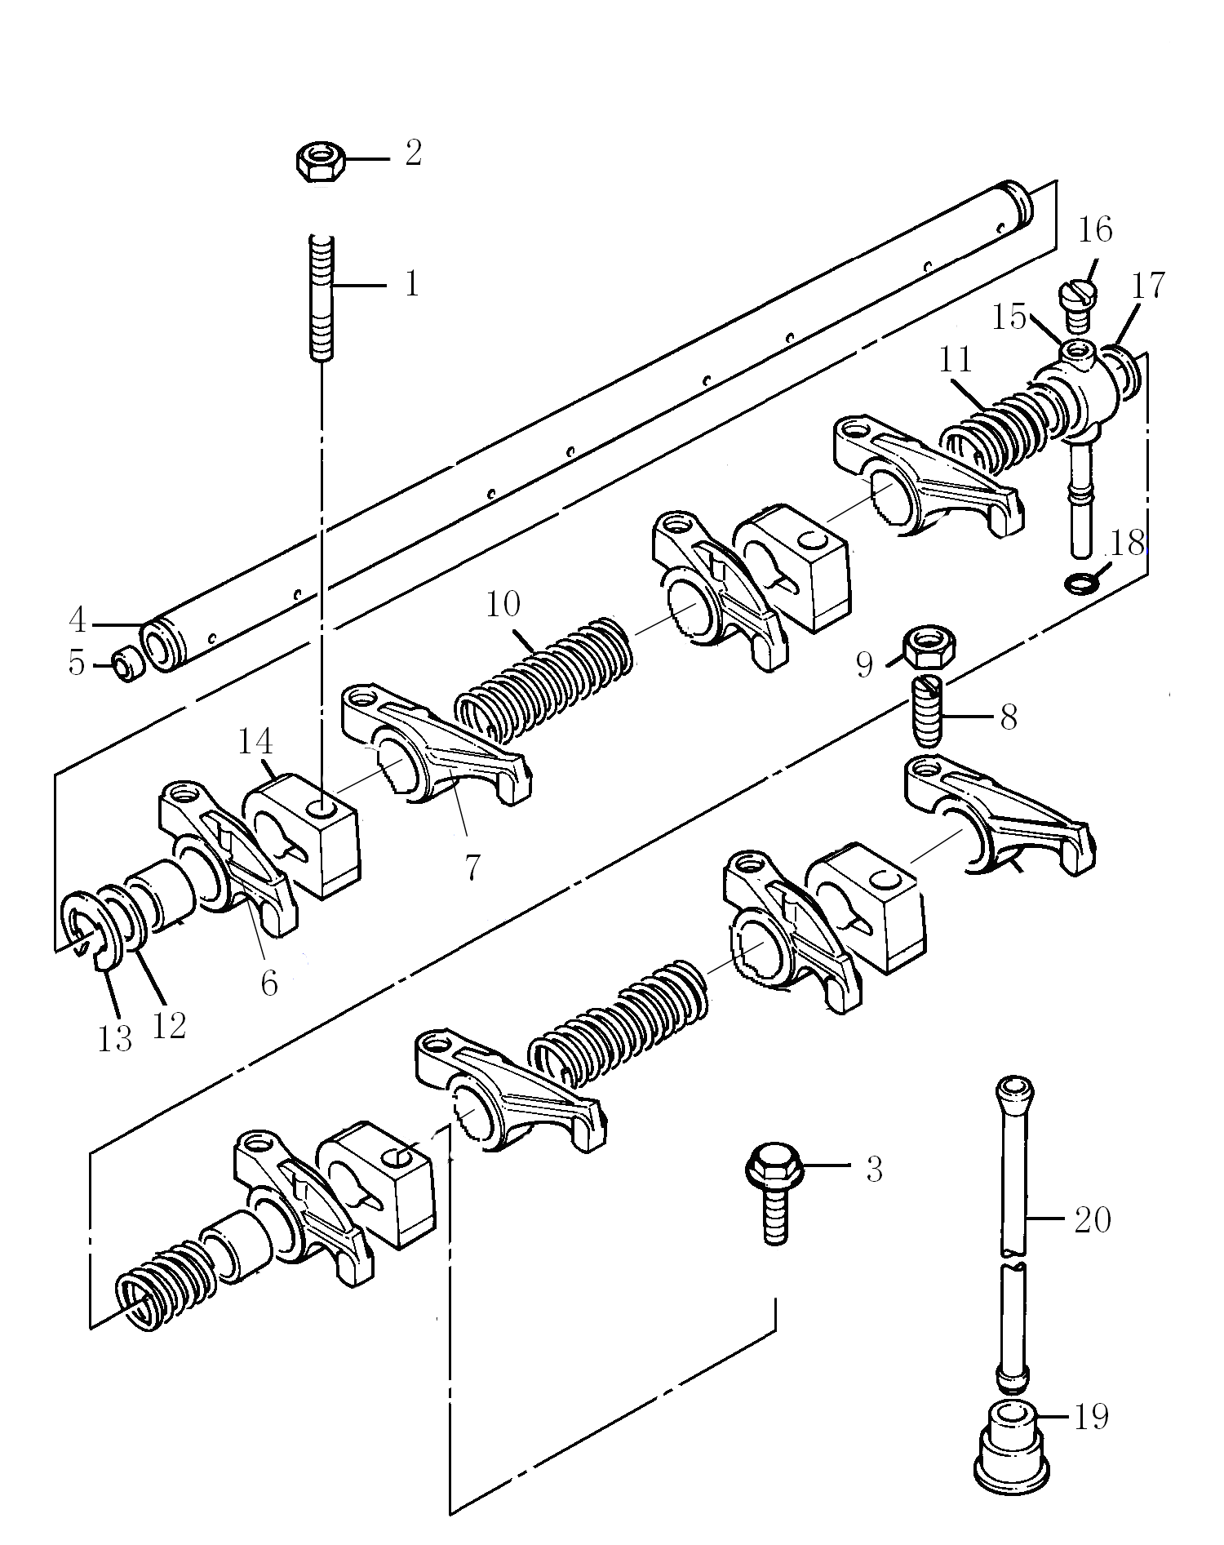
Rocker shaft摇臂轴 ACHA
Item  图示号 | Family No.  组件号 | Part No.  零件号 | Part Name  零件名称 |  | Qty.  数量
1 | AC10F 0052 | T2313H331 | 丝对 | Stud | 3
2 | AC10F 0058 | T2318A605 | 螺母 | Nut | 3
3 | AC10F 0061 | T2314J607 | 螺栓 | Screw | 1
4 | AC10F 0082 | T31411124 | 摇臂轴 | Rocker shaft | 1
5 | AC10F 0091 | T0650507 | 堵 | Plug | 2
6 | AC10F 0103 | T4115R306 | 摇臂(组件) | Lever assy. Rocker LH | 4
7 | AC10F 0109 | T4115R305 | 摇臂(组件) | Lever assy. Rocker RH | 4
8 | AC10F 0127 | T32114145 | 螺栓 | Screw | 8
9 | AC10F 0130 | T0576052 | 螺母 | Nut | 8
10 | AC10F 0133 | T31744123 | 弹簧 | Spring | 2
11 | AC10F 0136 | T31743108 | 弹簧 | Spring | 2
12 | AC10F 0163 | T33117434 | 垫圈 | Washer | 2
13 | AC10F 0166 | T0170151 | 卡簧 | Circlip | 2
14 | AC10F 0070 | T3818X901 | 支架 | Bracket | 4
15 | AC20N 0011 | T3775E012 | 进油接头 | Connection | 1
16 | AC20N 0020 | T2233022 | 螺栓 | Screw | 1
17 | AC20N 0025 | T3311K015 | 垫片 | Washer | 2
18 | AC20N 0023 | T33811113 | 橄榄体 | Olive | 1
19 | AC10J 0239 | T3142U031 | 挺柱 | Tappet | 8
20 | AC10J 0257 | T31434307 | 推杆 | Push rod | 8

Lubricating Oil Pump润滑油泵 ACHA

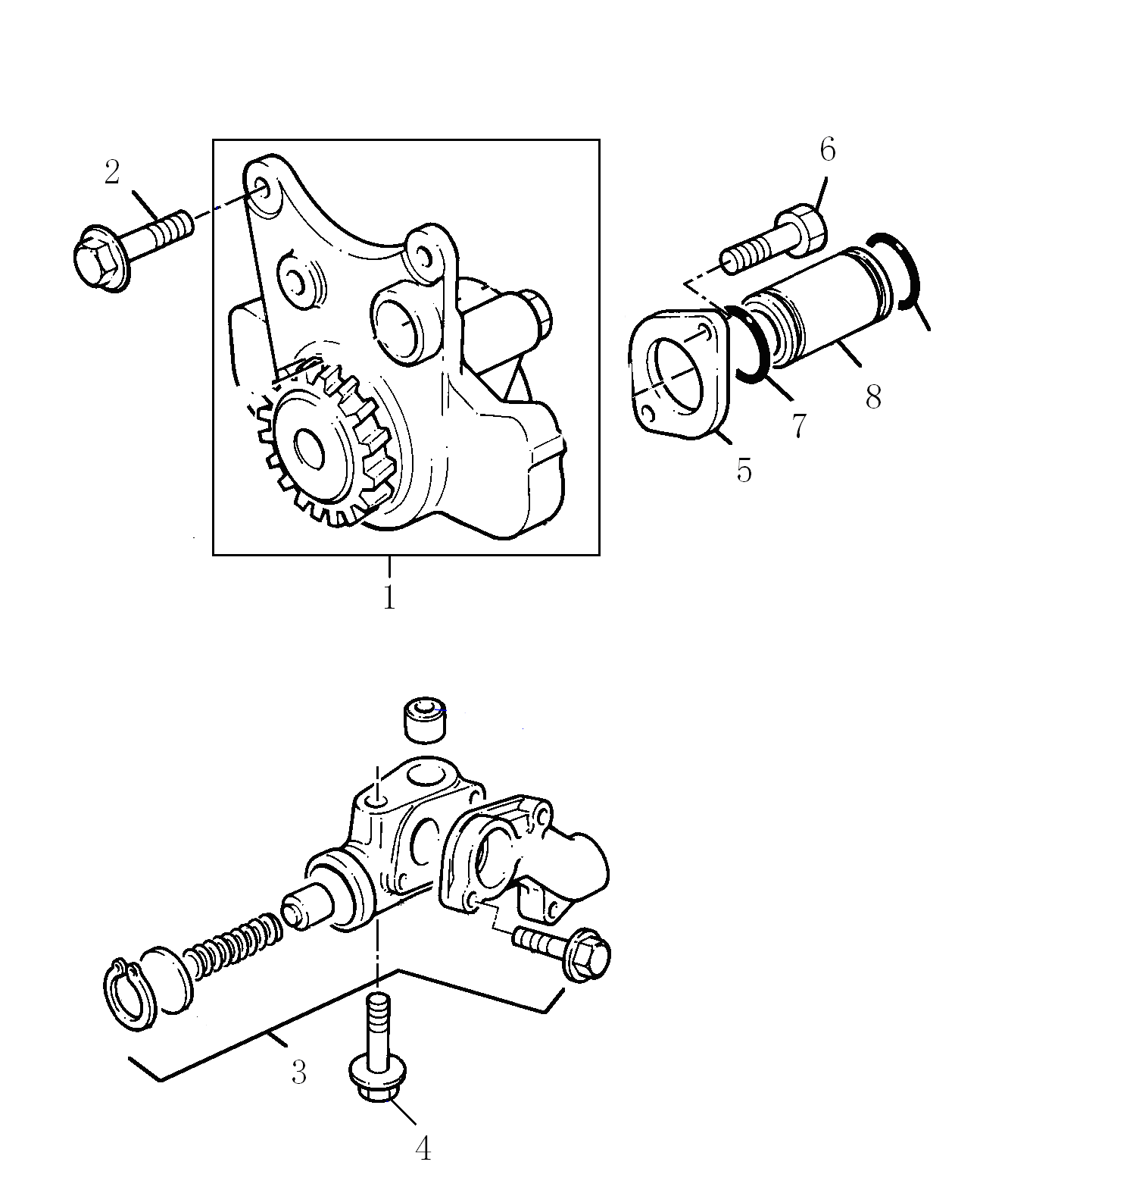
Lubricating Oil Pump润滑油泵 ACHA
Item  图示号 | Family No.  组件号 | Part No.  零件号 | Part Name  零件名称 |  | Qty.  数量
1 | AC20B 0007 | T4132F056C | 机油泵总成 | Lubricating Oil Pump | 1
2 | AC20B 0175 | T2314H005 | 螺栓 | Screw | 3
3 | AC20D 0046 | T4138A049 | 限压阀总成 | Relief valve | 1
4 | AC20D 0095 | T2314J011 | 螺栓 | Scre | 1
5 | AC20G 0038 | T3748C011 | 法兰 | Flange | 1
6 | AC20G 0076 | T2314H004 | 螺栓 | Screw | 2
7 | AC20G 0080 | T2415H201 | O 型圈 | O Ring | 2
8 | AC20G 0081 | T3343F012 | 油管 | Pipe | 1

Fuel Injection Equipment燃油喷射系统 ACHA

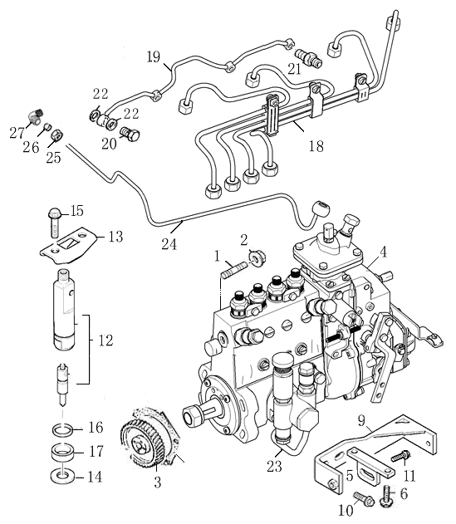

Fuel Injection Equipment燃油喷射系统 ACHA
Item  图示号 | Family No.  组件号 | Part No.  零件号 | Part Name  零件名称 |  | Qty.  数量
1 | AF17D 0004 | Q1201040F3S | 双头螺栓 | Stud | 4
2 | AF17D 0037 | T2318A604 | 螺母 | Nut | 4
3 | AF17D 0058 | T3117L113G | 直列泵齿轮 | Drive gear | 1
4 | AF17D 0094 | T832080297 | 喷油泵 | Fuel pump | 1
5 | AF17D 0191 | T732110044 | 支架 | Bracket | 1
6 | AF17D 0192 | T2314H003 | 螺栓 | Screw | 2
7 | AF17D 0185 | Q40110 | 平垫 | Washer | 2
8 | AF17D 0186 | Q40310 | 弹簧垫 | Spring washer | 2
9 | AF17D 0194 | T732110044 | 支架 | Bracket | 1
10 | AF17D 0195 | T2314J002 | 螺栓 | Screw | 2
11 | AF17D 0196 | T2314H003 | 螺栓 | Screw | 1
12 | AF17E 0001 | T73302131 | 喷油器总成 | Atomizer Assembly | 1
13 | AF17E 0004 | T3662K002 | 压板 | Clamp | 4
14 | AF17E 0007 | T0921173 | 垫圈 | Washer | 4
15 | AF17E 0008 | T2314H006 | 螺栓 | Screw | 8
16 | AF17E 0035 | T33813129 | 隔圈 | Spacer | 4
17 | AF17E 0037 | T33813131 | 防尘盖 | Duster Seal | 4
18 | AF17M 0002 | T73208142 | 高压油管 | High pressure pipe | 1
19 | AF17N 0001 | T733120007 | 油管 | Pipe | 1
20 | AF17N 0034 | T3218R005 | 过油螺栓 | Screw | 3
21 | AF17N 0043 | T3355V002 | 过油螺栓 | Screw | 1
22 | AF17N 0049 | T2411101 | 垫圈 | Washer | 8
23 | AF20L 0001 | T73209401 | 润滑油管 | Lubricating pipe | 1
24 | AF33G 0030 | T732320002 | 进气补偿管 | Air inlet  Compensating pipe | 1
25 | AF33G 0031 | T33225412 | 螺母 | Nut | 1
26 | AF33G 0034 | T33811112 | 橄榄体 | Olive | 1
27 | AF33G 0041 | T0201047 | 弯管 | Elbow | 1

Flywheel Housing飞轮壳 CDHA

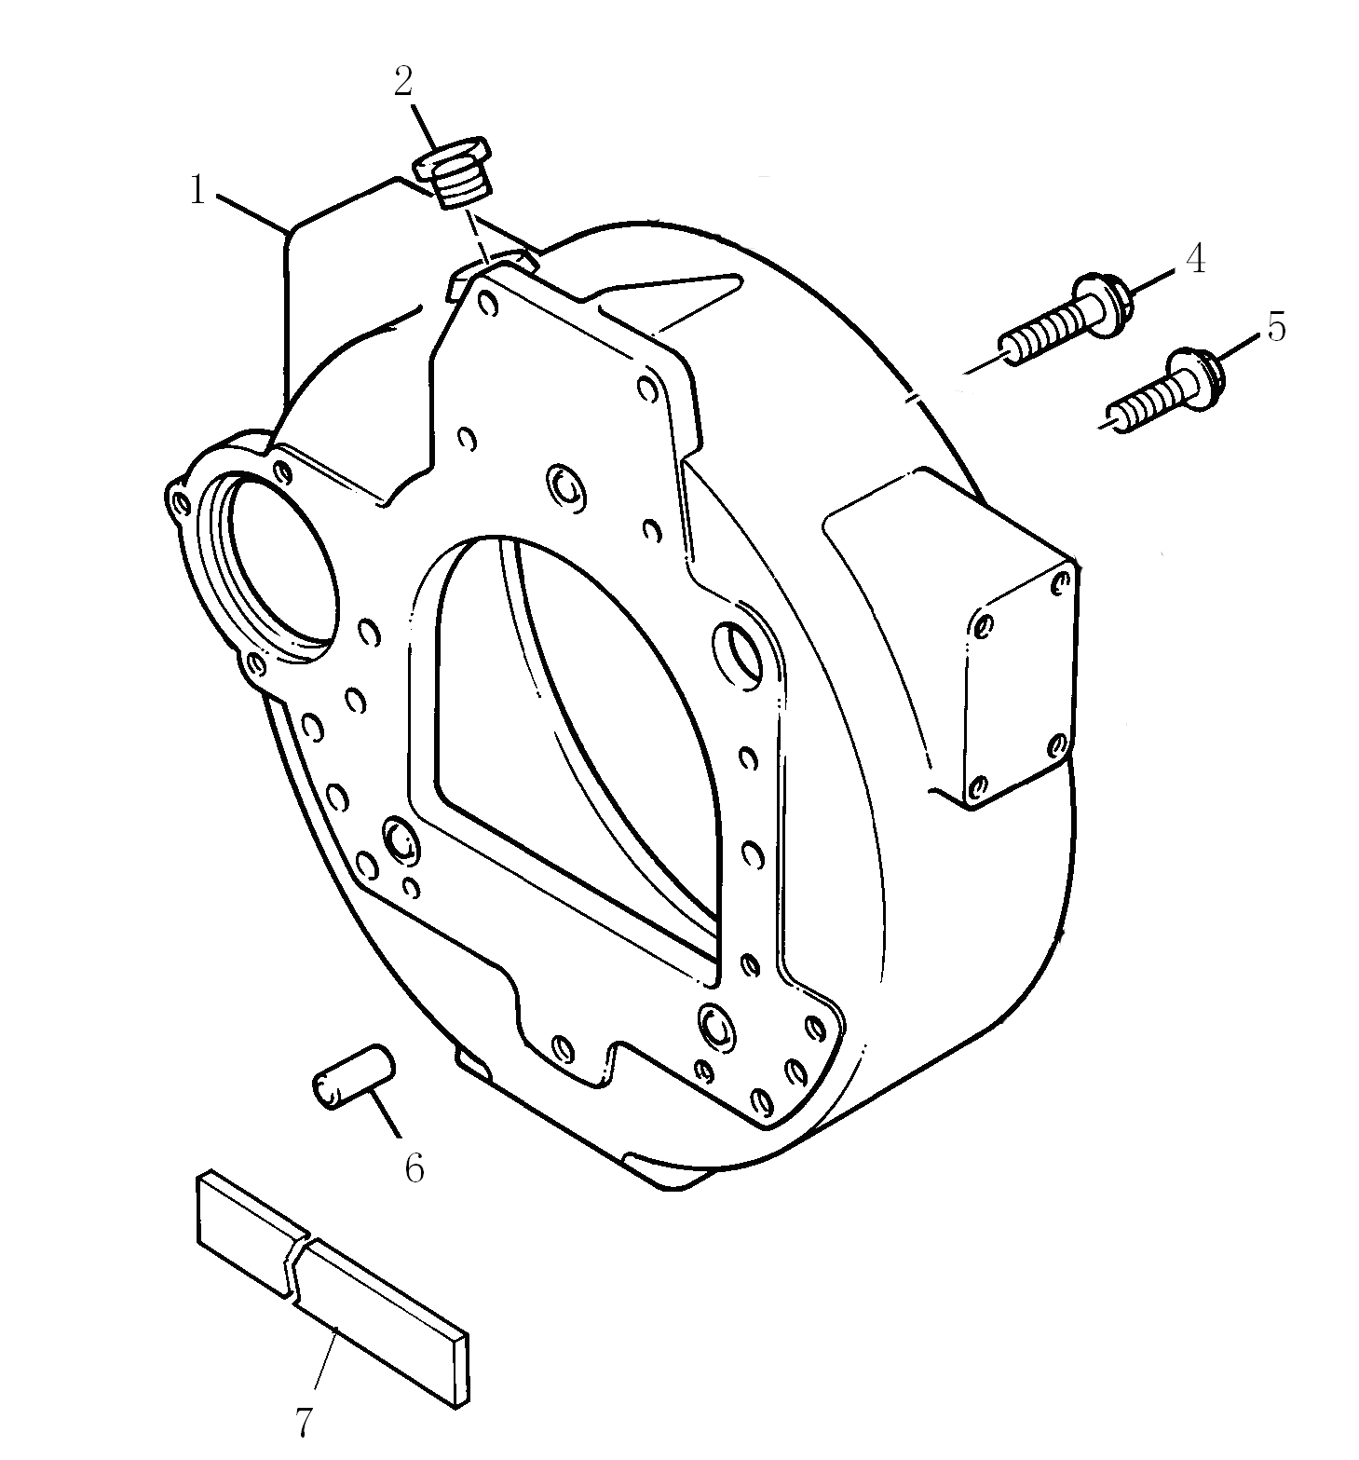

Flywheel Housing飞轮壳 CDHA
Item  图示号 | Family No.  组件号 | Part No.  零件号 | Part Name  零件名称 |  | Qty.  数量
1 | CD30A 0198 | T3713K023B | 飞轮壳 | Flywheel housing | 1
2 | CD30A 0227 | Q/0501-05 | 螺塞M16×1.5 | Screw plug | 1
3 | CD30A 0227 | T71201002 | 螺堵 | Screw plug | 1
4 | CD30A 0255 | T2314J204 | 飞轮壳螺栓 | Screw | 6
5 | CD30A 0264 | T2314J603 | 飞轮壳螺栓 | Screw | 2
6 | CD30A 0294 | T0350025 | 飞轮壳定位销 | Dowel | 2
7 | CD30A 0358 | T36843154 | 密封条 | SeaL | 1

Flywheel & Starter Ring飞轮及启动齿圈 DDHA

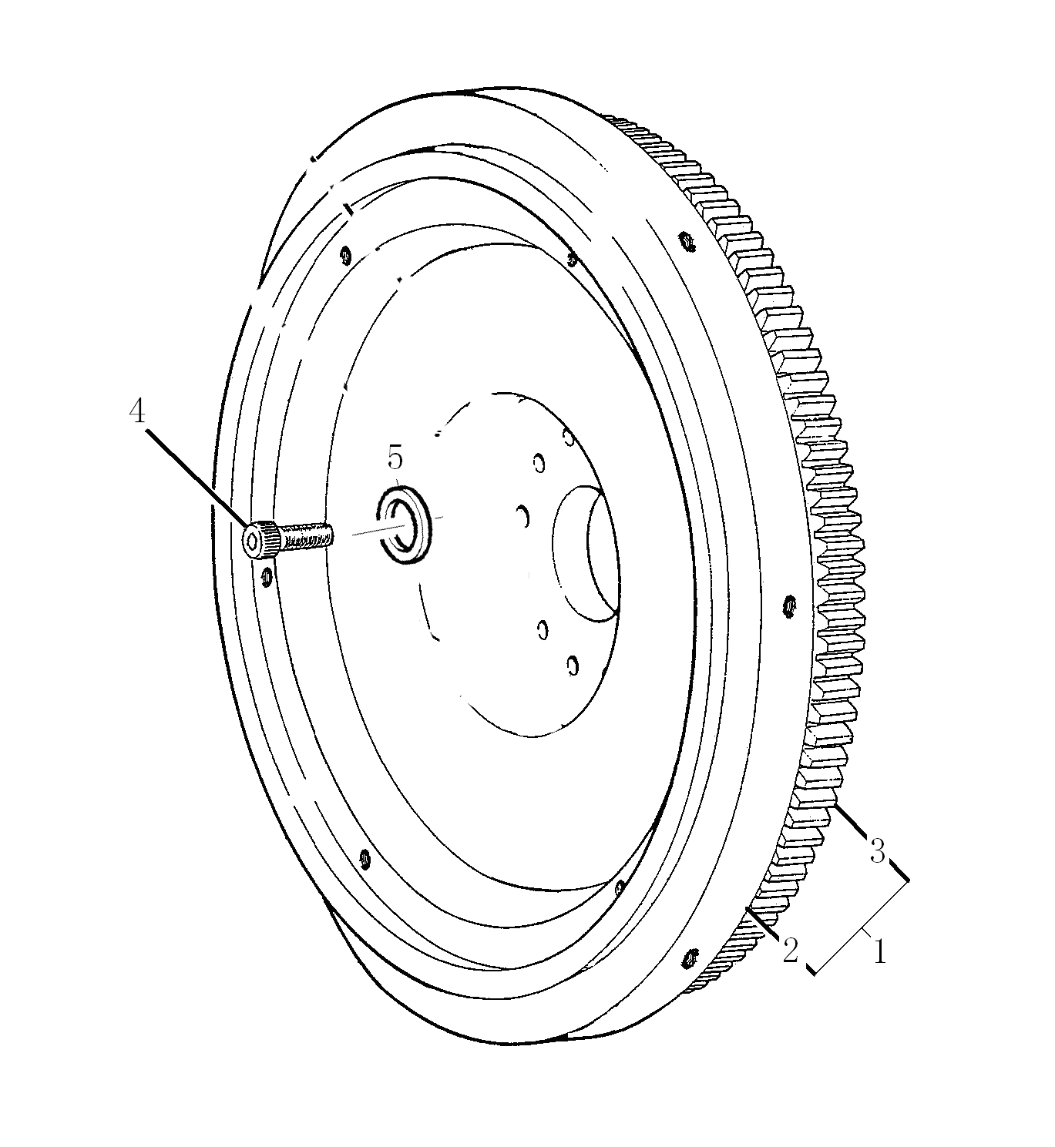
Flywheel & Starter Ring飞轮及启动齿圈 DDHA
Item  图示号 | Family No.  组件号 | Part No.  零件号 | Part Name  零件名称 |  | Qty.  数量
1 | DD30B 0004 | T63607101K1 | 飞轮部 | Flywheel assy. | 1
2 |  | T31162121B | 齿圈 | Starter ring | 1
3 |  | T63640001 | 飞轮 | Flywheel | 1
4 | DD30B 0019 | T2185103 | 螺栓 | Screw | 10
5 | DD30B 0031 | T33117127 | 垫圈 | Washer | 10

Starter motor启动马达 EDHA

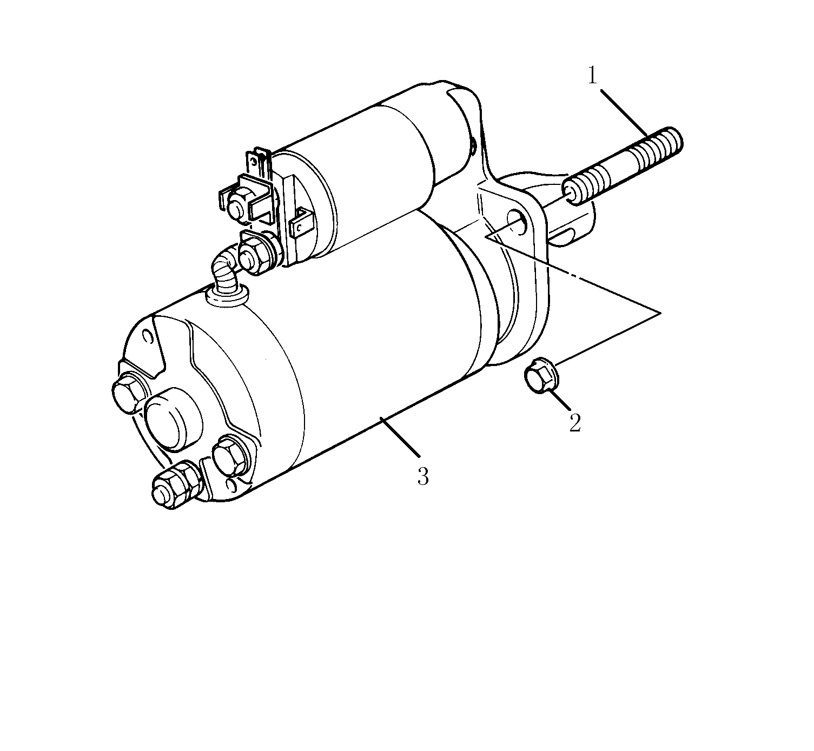

Starter motor启动马达 EDHA
Item  图示号 | Family No.  组件号 | Part No.  零件号 | Part Name  零件名称 |  | Qty.  数量
1 | ED25A 0036 | T2313C078 | 双头螺栓 | Stud | 3
2 | ED25A 0042 | Q340B10 | 螺母 | Nut | 3
3 | ED25A 0007 | T837010021 | 起动马达 | Starter motor | 1

Fan Drive风扇驱动装置 FBHA

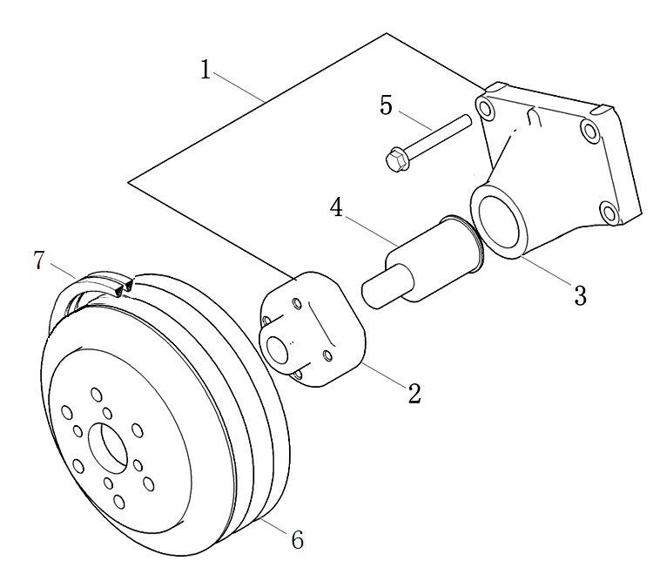
Fan Drive风扇驱动装置 FBHA
Item  图示号 | Family No.  组件号 | Part No.  零件号 | Part Name  零件名称 |  | Qty.  数量
1 | FB10B 0001 | T839010008 | 风扇驱动壳 | Fan drive housing | 1
2 |  | T3347E011 | HUB | HUB | 1
3 |  | T3751C131 | 支架 | bracket | 1
4 |  | T728040003 | 轴承 | Bearing | 1
5 | FB10B 0010 | T2314J015 | 螺栓 | Screw | 1
6 | FB10B 0025 | T63910008 | 皮带轮 | Pulley | 1
7 | FB10B 0040 | T74401017 | 皮带 | Belt | 2

Lubricating Oil Sump 润滑油底壳 GBHA

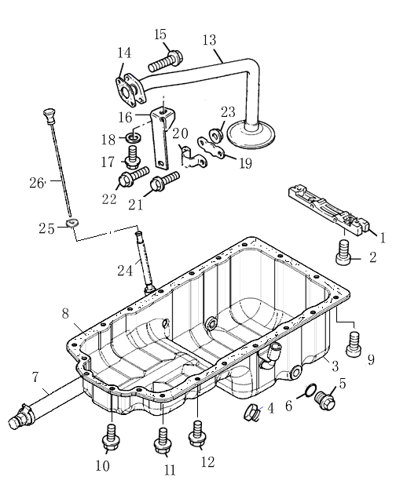
Lubricating Oil Sump 润滑油底壳 GBHA
Item  图示号 | Family No.  组件号 | Part No.  零件号 | Part Name  零件名称 |  | Qty.  数量
1 | GB10A 0025 | T738060002 | 桥架 | Bridge Piece | 1
2 | GB10A 0035 | T2311D039 | 螺栓 | Screw | 2
3 | GB20A 0001 | T73803015 | 油底总成 | Oil sump assy. | 1
4 | GB20A 0043 | T2431A016 | 堵 | Plug | 1
5 | GB20A 0052 | T712030028 | 堵 | Plug | 1
6 | GB20A 0059 | T2415715 | O 型圈 | O ring | 1
7 | GB20A 0060 | T73802100 | 放油胶管 | Oil drain hose assy. | 1
8 | GB20A 0088 | T36815736 | 垫 | Joint | 1
9 | GB20A 0160 | T2314H003 | 螺栓 | Screw | 2
10 | GB20A 0200 | T2314H003 | 螺栓 | Screw | 4
11 | GB20A 0205 | T2314H003 | 螺栓 | Screw | 2
12 | GB20A 0208 | T2314H003 | 螺栓 | Screw | 12
13 | GB20F 0013 | T3575A046 | 油管总成 | Oil pipe assy. | 1
14 | GB20F 0025 | T36832137 | 垫 | Joint | 1
15 | GB20F 0034 | T2314H007 | 螺栓 | Screw | 2
16 | GB20F 0049 | T3821D012 | 支架 | Bracket | 1
17 | GB20F 0055 | T2314H002 | 螺栓 | Screw | 1
18 | GB20F 0061 | T0920484 | 垫圈 | Washer | 1
19 | GB20F 0248 | T3661V002 | 板 | Plate | 1
20 | GB20F 0252 | T3661C002 | 卡子 | Clip | 1
21 | GB20F 0256 | T2314F002 | 螺栓 | Screw | 1
22 | GB20F 0257 | T2314F004 | 螺栓 | Screw | 1
23 | GB20F 0259 | T2318A602 | 螺母 | Nut | 2
24 | GB33V 0004 | T3577A125 | 油尺管总成 | Dipstick tube assy. | 1
25 | GB33V 0022 | T33812116 | 橄榄体 | Olive | 1
26 | GB33V 0130 | T3178C069 | 油尺 | Dipstick | 1

Cover Plate& Filler盖板及加油口 ZJHA

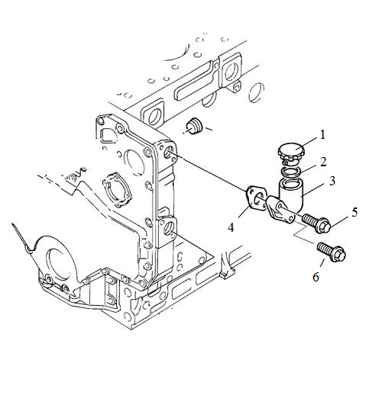
Cover Plate& Filler盖板及加油口 ZJHA
Item  图示号 | Family No.  组件号 | Part No.  零件号 | Part Name  零件名称 |  | Qty.  数量
1 | HB10B 0221 | T74001202 | 加油口盖 | Filler cap | 1
2 | HB10B 0222 | T714010020 | O形橡胶密封圈 | O ring | 1
3 | HB10B 0220 | T74001001 | 加油口 | Filler | 1
4 | HB10B 0208 | T3683H006 | 加油口垫 | Joint | 1
5 | HB10B 0241 | T2314H010 | 螺栓 | Screw | 1
6 | HB10B 0241 | T2314H007 | 螺栓 | Screw | 1

Cylinder Head Cover气缸盖罩 HBHA

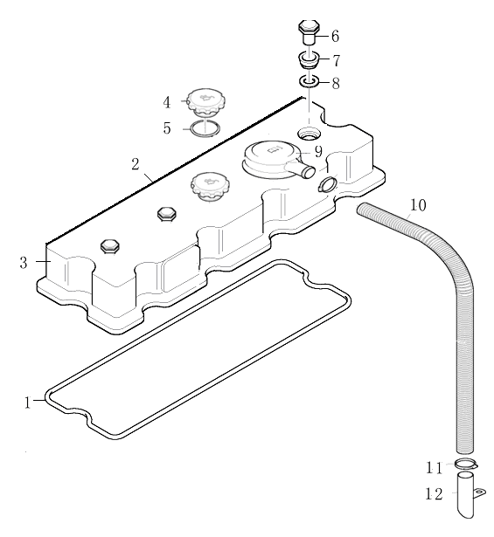
Cylinder Head Cover气缸盖罩 HBHA
Item  图示号 | Family No.  组件号 | Part No.  零件号 | Part Name  零件名称 |  | Qty.  数量
1 | HB10G 0001 | T3681A021A | 缸盖罩垫 | Cyl. head cover joint | 1
2 | HB10G 0002 | T3687A507A | 防尘条 | Seal | 1
3 | HB10G 0006 | T4142X046E | 缸盖罩总成 | Cyl. head cover assy. | 1
4 | HB10G 0008 | T3781A003 | 加油口盖 | Filler | 1
5 | HB10G 0009 | T3381J002 | O型圈 | O ring | 1
6 | HB10G 0040 | T3274A003 | 螺母 | Nut | 3
7 | HB10G 0042 | T0920009 | 垫圈 | Washer | 3
8 | HB10G 0043 | T33817135 | 密封垫 | Washer | 3
9 | HB10G 0181 | T4133J001 | 呼吸器 | Breather | 1
10 | HB15D 0362 | T33881108D | 呼吸管 | Breather pipe | 1
11 | HB15D 0392 | T0180064 | 环箍 | Clip | 1
12 | HB15D 0435 | T36567411 | 管夹 |  | 1

Lub. oil Filter 机油滤清器 VBHA

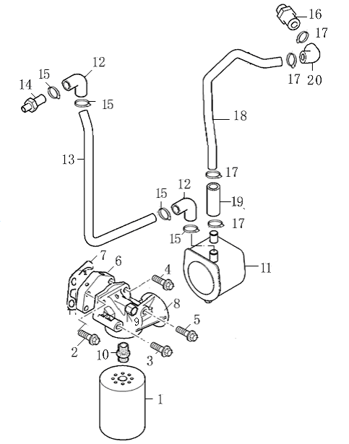
Lub. oil Filter 机油滤清器 VBHA
Item  图示号 | Family No.  组件号 | Part No.  零件号 | Part Name  零件名称 |  | Qty.  数量
1 | JB20C 0016 | T64101001 | 机油滤清器 | Lub. oil Filter | 1
2 | JB20C 0120 | T2314J010 | 螺栓 | Screw | 1
3 | JB20C 0124 | T2314J019 | 螺栓 | Screw | 1
4 | JB20C 0128 | T2314J040 | 螺栓 | Screw | 1
5 | JB20C 0132 | T2314J049 | 螺栓 | Screw | 1
6 | JB20C 0154 | T3773T101 | 垫板 | Plate | 1
7 | JB20C 0064 | T3686T006 | 垫片 | Joint | 1
8 | JB20C 0079 | T3773P312C | 机油滤清器座 | Head | 1
9 | JB20C 0178 | T0650586 | 螺堵 | Screw plug | 1
10 | JB20C 0296 | T33554128B | 接头 | Connection | 1
11 | JB22H 0053 | T74202012 | 油冷器 | Oil cooler | 1
12 | JB22T 0017 | T742020041 | 弯胶管 | Pipe | 1
13 | JB22T 0018 | T742020021 | 出水管 | Water outlet pipe | 1
14 | JB22T 0019 | T74202003 | 接头 | Connection | 1
15 | JB22T 0143 | T2481863 | 卡箍 | Clip | 4
16 | JB23A 0001 | T64202014 | 接头 | Connection | 1
17 | JB23A 0010 | T2481863 | 卡箍 | Clip | 4
18 | JB23A 0011 | T4126E068G | 进水管 | Water inlet pipe | 1
19 | JB23A 0013 | T742020042 | 连接胶管 | Connection hose | 1
20 | JB23A 0014 | T742020041 | 弯胶管 | hose | 1

Front End Drive Input前端驱动输入 KBHA

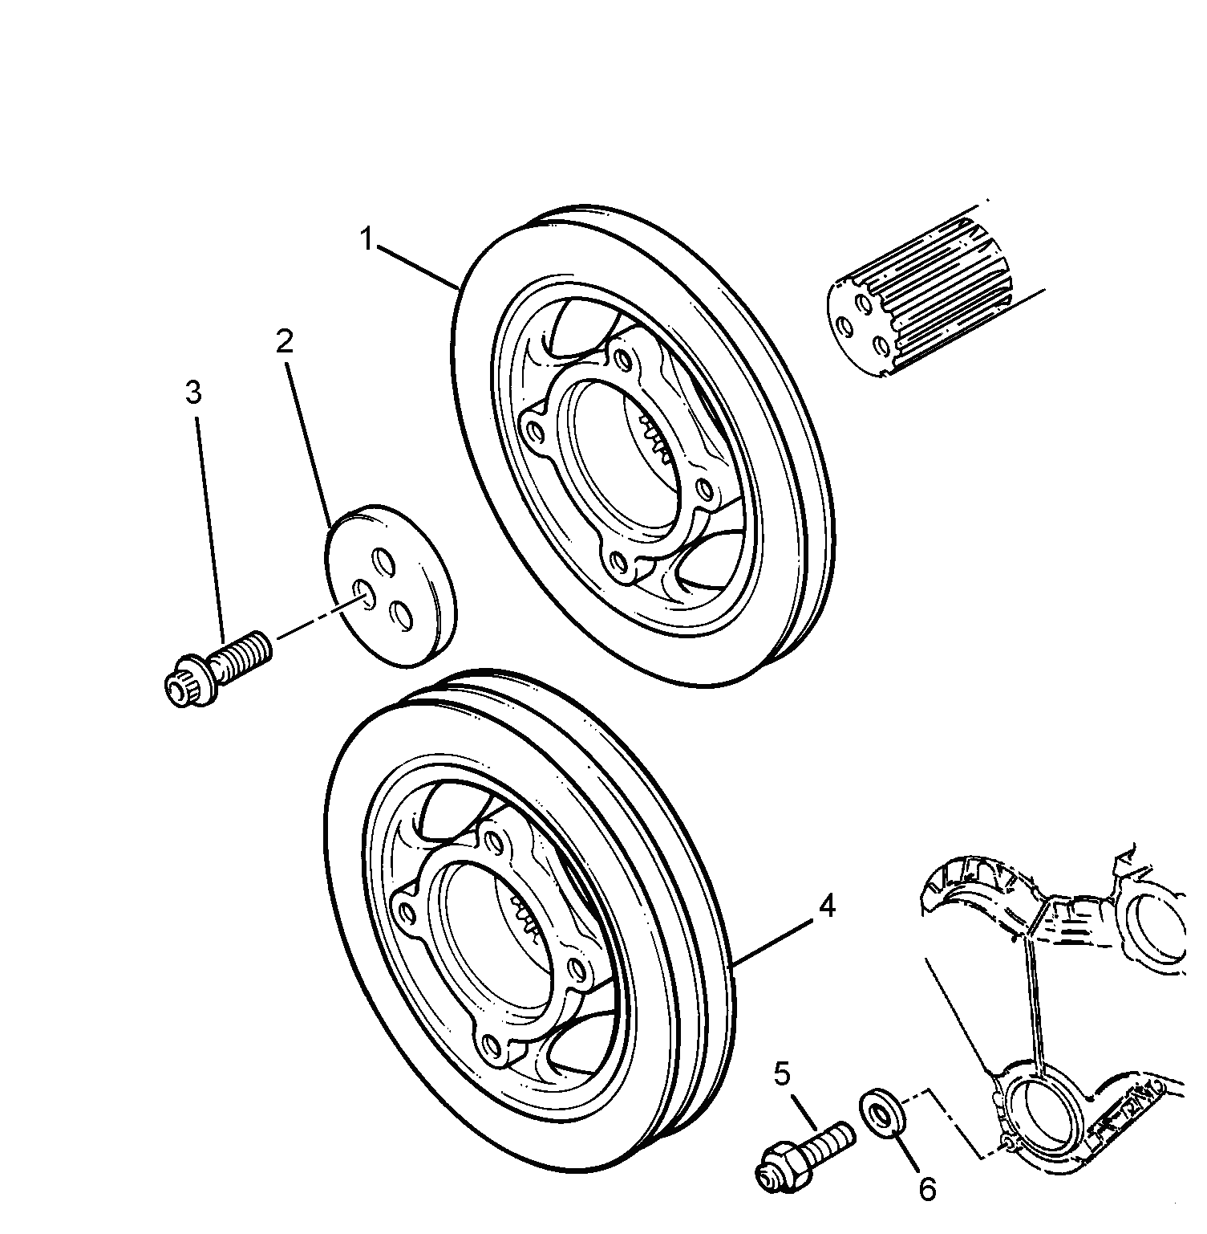
Front End Drive Input前端驱动输入 KBHA
Item  图示号 | Family No.  组件号 | Part No.  零件号 | Part Name  零件名称 |  | Qty.  数量
1 | KB10L 0025 | T3115T051B | 皮带轮 | Pulley | 1
2 | KB10L 0086 | T3241N001 | 止推块 | Thrust block | 1
3 | KB10L 0092 | T32186137 | 螺栓 | Screw | 3
4 | KB10L 0100 | T74305005 | 联接皮带轮 | Pulley | 1
5 | KB10L 0101 | T61104103 | 联接螺栓 | Screw | 4
6 | KB10L 0102 | Q40312 | 弹簧垫圈 | Spring washer | 4

Water Pump & Thermostat水泵及节温器 LBHA

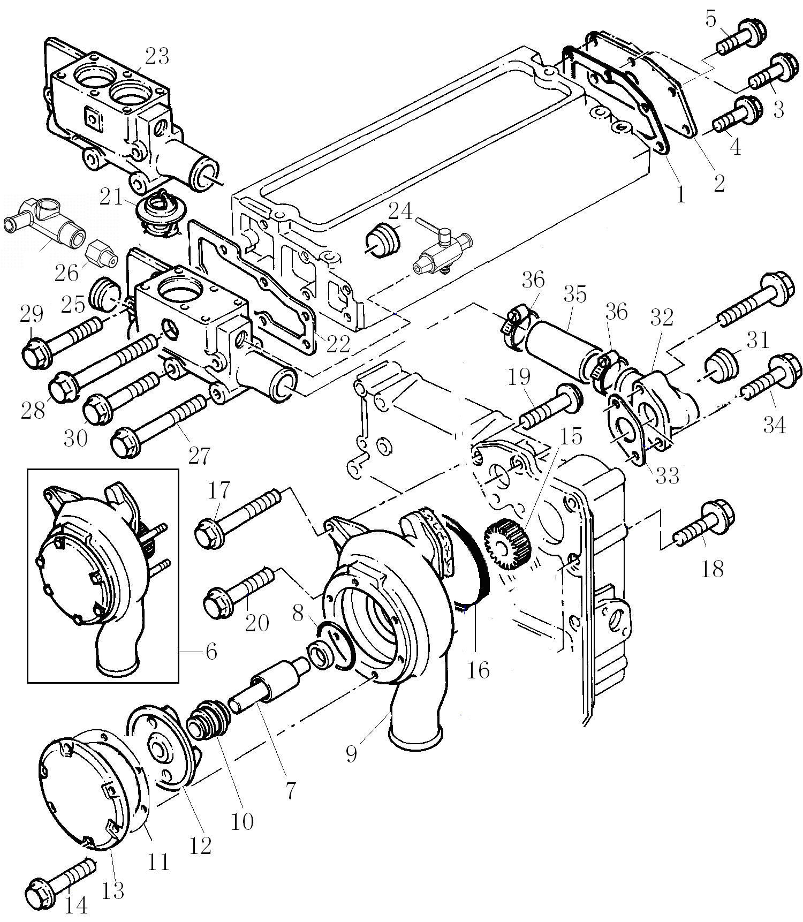

Water Pump & Thermostat水泵及节温器 LBHA
Item  图示号 | Family No.  组件号 | Part No.  零件号 | Part Name  零件名称 |  | Qty.  数量
1 | LB10E 0140 | T3685R005 | 垫 | Joint | 1
2 | LB10E 0145 | T3623K007 | 缸盖后盖板 | Cover | 1
3 | LB10E 0156 | T2314H002 | 螺栓 | Screw | 1
4 | LB10E 0157 | T2314H002 | 螺栓 | Screw | 3
5 | LB10E 0170 | T2314J002 | 螺栓 | Screw | 2
6 | LB22C 0049 | T4131E011C | 水泵 | Water pump | 1
7 |  | T2538624 | 轴 | Shaft | 1
8 |  | T2415B155 | O 型圈 | O ring | 1
9 |  | T3771D045 | 泵体 | Body | 1
10 |  | T2418M006A | 密封圈 | Seal | 1
11 |  | T3382P004 | 密封垫 | Joint | 1
12 |  | T3746X055A | 叶轮 | Impeller | 1
13 |  | T3243C002 | 盖 | Cover | 1
14 |  | T2314M033 | 螺栓 | Screw | 6
15 |  | T3117A035 | 齿轮 | Gear | 1
16 | LB22C 0143 | T2415H494 | O 型圈 | O ring | 1
17 | LB22C 0145 | T2314H015 | 螺栓 | Screw | 1
18 | LB22C 0176 | T2314N043 | 螺栓 | Screw | 3
19 | LB22C 0177 | T2314H006 | 螺栓 | Screw | 1
20 | LB22C 0178 | T2314H006 | 螺栓 | Screw | 1
21 | LB22D 0007 | T74405005 | 节温器 | Thermostat | 1
22 | LB22D 0028 | T3685F005 | 垫 | Joint | 1
23 | LB22D 0040 | T744030026 | 节温器壳 | Housing | 1
24 | LB22D 0054 | T2431154M | 堵 | Plug | 1
25 | LB22D 0092 | T2431154M | 堵 | Plug | 1
26 | LB22D 0056 | Q618B03 | 堵 | Plug | 1
27 | LB22D 0124 | T2314K165 | 螺栓 | Screw | 2
28 | LB22D 0136 | T2314H015 | 螺栓 | Screw | 1

Water Pump & Thermostat水泵及节温器 LBHA

Water Pump & Thermostat水泵及节温器 LBHA
Item  图示号 | Family No.  组件号 | Part No.  零件号 | Part Name  零件名称 |  | Qty.  数量
29 | LB22D 0160 | T2314H008 | 螺栓 | Screw | 2
30 | LB22D 0161 | T2314J004 | 螺栓 | Screw | 2
31 | LB22P 0092 | T2431154 | 堵 | Plug | 1
32 | LB22P 0095 | T3764E061 | 接头 | Connnection | 1
33 | LB22P 0097 | T3683N004 | 垫圈 | Joint | 1
34 | LB22P 0100 | T2314H004 | 螺栓 | Screw | 2
35 | LB22P 0110 | T33854114 | 胶管 | Hose | 1
36 | LB22P 0112 | T0180067 | 卡箍 | Clip | 2

Water Outlet 水出口 LDHA

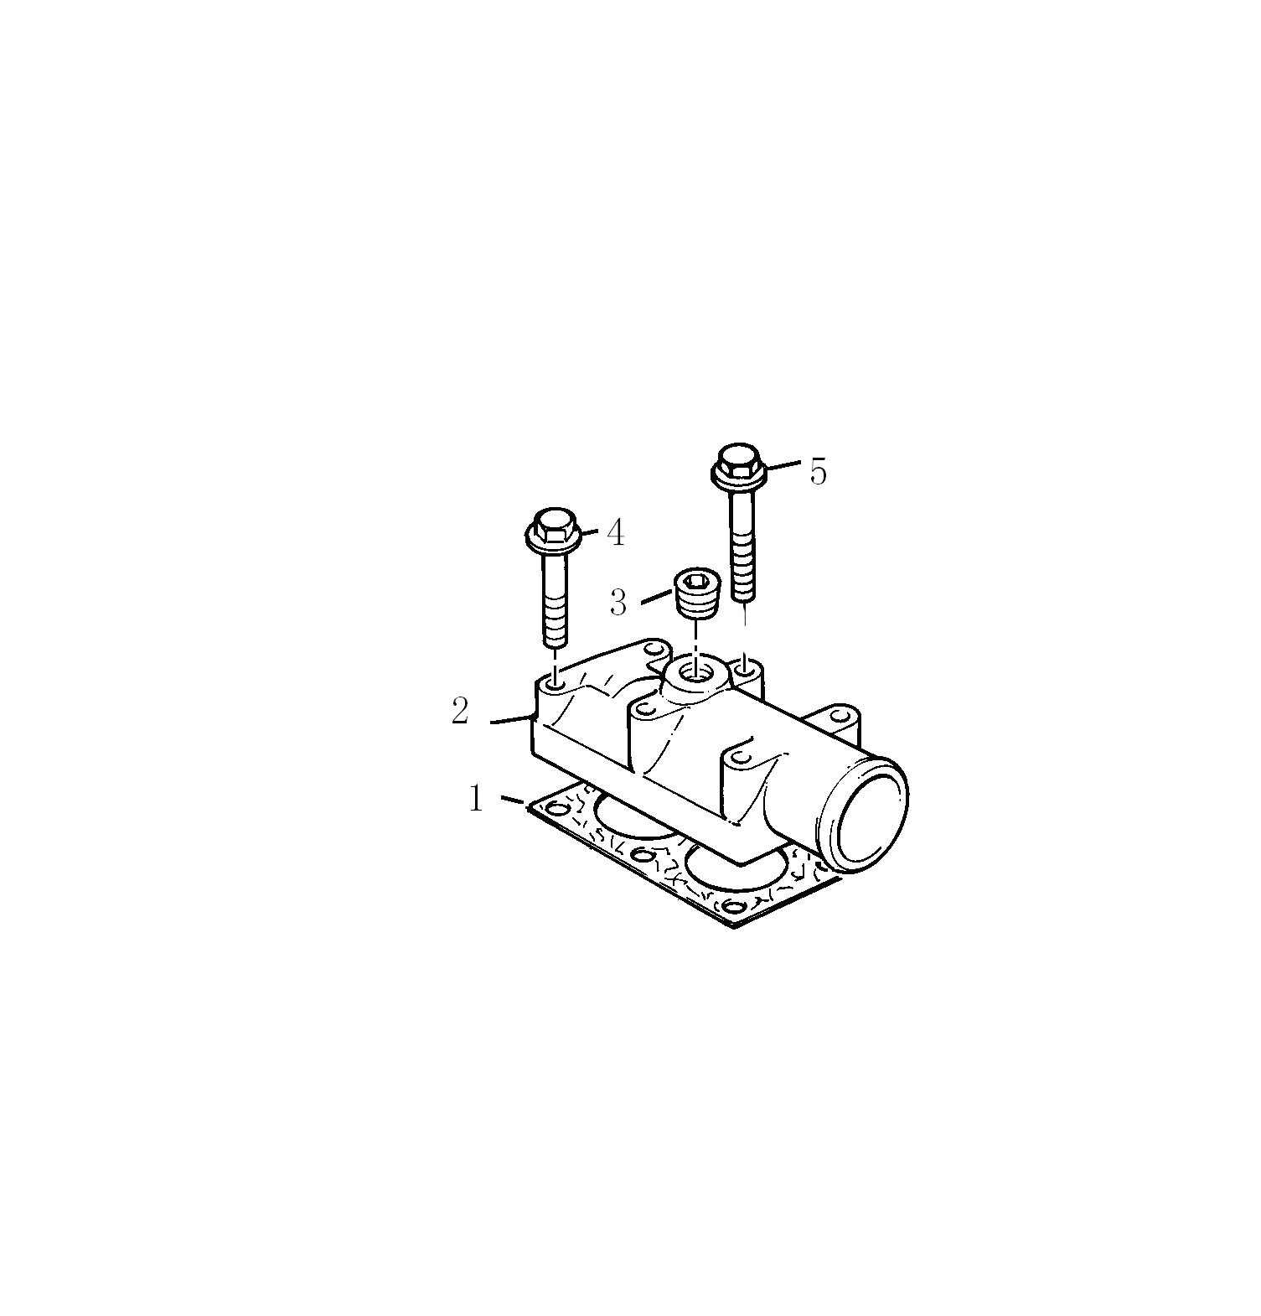
Water Outlet 水出口 LDHA
Item  图示号 | Family No.  组件号 | Part No.  零件号 | Part Name  零件名称 |  | Qty.  数量
1 | LD22P 0001 | T3684A004 | 垫 | Joint | 1
2 | LD22P 0006 | T3776E002 | 出水口 | Water outlet | 1
3 | LD22P 0019 | T0650593 | 堵 | Plug | 1
4 | LD22P 0040 | T2314K161 | 螺栓 | Screw | 4
5 | LD22P 0041 | T2314H008 | 螺栓 | Screw | 2

Fan Drive风扇驱动装置 FBHA

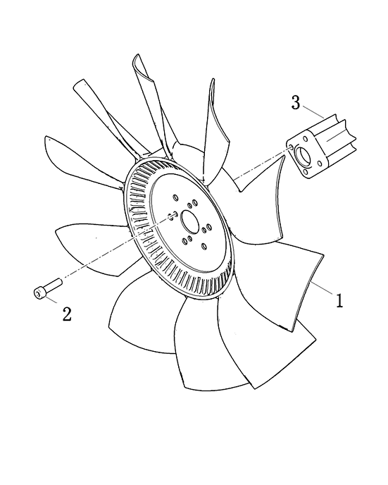
Fan Drive风扇驱动装置 FBHA
Item  图示号 | Family No.  组件号 | Part No.  零件号 | Part Name  零件名称 |  | Qty.  数量
1 | MB22B 0002 | T73901005 | 吸风扇 | Fan | 1
2 | MB22B 0037 | T3748W241 | 隔圈 | Extension | 1
3 | MB22B 0014 | Q18408110  TF3 | 螺栓 | Screw | 1

Alternator & Generator交流发电机及发电机 NDHA

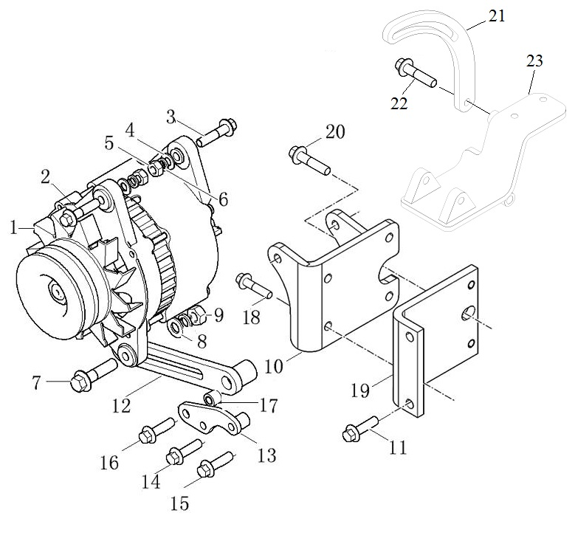

Alternator & Generator交流发电机及发电机 NDHA
Item  图示号 | Family No.  组件号 | Part No.  零件号 | Part Name  零件名称 |  | Qty.  数量
1 | ND24A 0004 | T845010011 | 发电机 | Alternator | 1
2 | ND24A 0054 | T2314H007 | 螺栓 | Screw | 1
3 | ND24A 0094 | T2314H008 | 螺栓 | Screw | 1
4 | ND24A 0095 | T0920497 | 平垫 | Washer | 2
5 | ND24A 0097 | Q340B08 | 螺母 | Nut | 2
6 | ND24A 0098 | Q40308 | 弹簧垫圈 | Spring washer | 2
7 | ND24A 0133 | T2314J006 | 螺栓 | Screw | 1
8 | ND24A 0142 | T2131A010 | 平垫 | Washer | 2
9 | ND24A 0200 | T2318A634 | 螺母M10 | Nut | 1
10 | ND24B 0004 | T3827H025B | 支架 | Bracket | 1
11 | ND10B 0130 | T2314H013 | 螺栓 | Screw | 2
12 | ND24B 0322 | T3753V014A | 调节杆 | Lever | 1
13 | ND24B 0344 | T3753V016 | 支架 | Bracket | 1
14 | ND24B 0345 | T2314H018 | 螺栓 | Screw | 1
15 | ND24B 0346 | T2314H008 | 螺栓 | Screw | 1
16 | ND24B 0347 | T2314J004 | 螺栓 | Screw | 1
17 | ND24B 0348 | T64502110 | 隔圈 | Spacer | 1
18 | ND24C 0011 | T2314H002 | 螺栓 | Screw | 4
19 | ND24C 0020 | T3641P004D | 连接板 | Connection plate | 1
20 | ND24C 0022 | T2314J003 | 螺栓 | Screw | 1
21 | ND24C 0249 | T745050024 | 空调调节杆 | Lever | 1
22 | ND24C 0252 | T2314J003 | 螺栓 | Screw | 1
23 | ND24C 0320 | T745110046 | 空调支架 | Bracket | 1

Gear Drive Auxiliary Drive Option 齿轮驱动/转向助力选用 QDHA

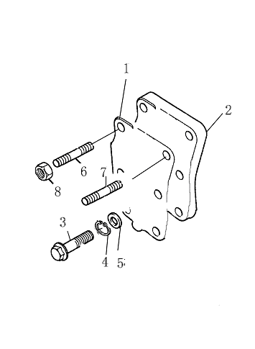
Gear Drive Auxiliary Drive Option 齿轮驱动/转向助力选用 QDHA
Item  图示号 | Family No.  组件号 | Part No.  零件号 | Part Name  零件名称 |  | Qty.  数量
1 | QD10B 0001 | T72201007A | 垫片 | Joint | 1
2 | QD10B 0002 | T72201006 | 惰轮盖板 | Cover playe | 1
3 | QD10B 0003 | Q150B0820Q | 螺栓 | Screw | 4
4 | QD10B 0004 | Q40308 | 弹簧垫 | Washer | 4
5 | QD10B 0005 | Q40108 | 平垫圈 | Spring washer | 4
6 | QD10B 0006 | T2313H321 | 双头螺栓 | Stud | 1
7 | QD10B 0007 | T3254T001 | 双头螺栓 | Stud | 1
8 | QD10B 0008 | T2318A605 | 螺母 | Nut | 3

Induction & Exhaust System进、排气系统 SBHA

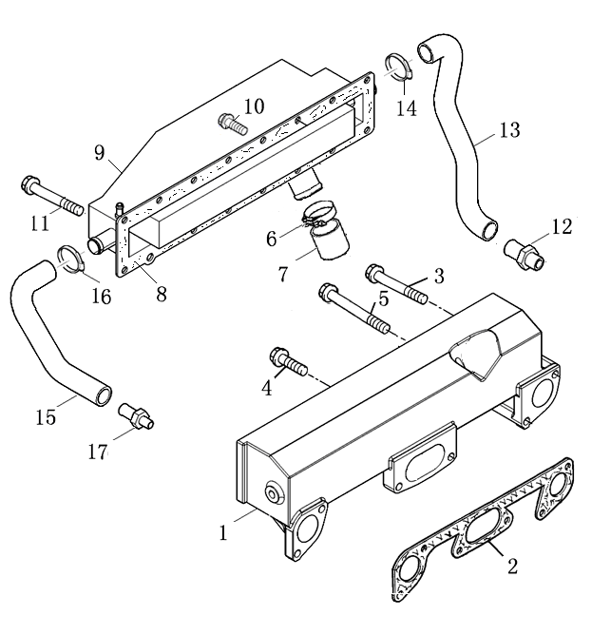
Induction & Exhaust System进、排气系统 SBHA
Item  图示号 | Family No.  组件号 | Part No.  零件号 | Part Name  零件名称 |  | Qty.  数量
1 | SB15A 0010 | T3777E233F | 进气管 | Induction manifold | 1
2 | SB15A 0016 | T3688C024 | 垫 | Joint | 1
3 | SB15A 0020 | T2314J018 | 螺栓 | Screw | 2
4 | SB15A 0021 | T2314J004 | 螺栓 | Screw | 3
5 | SB15A 0027 | T2314J018 | 螺栓 | Screw | 1
6 | SB15E 0020 | T0180069 | 喉箍 | Clip | 2
7 | SB15E 0021 | T3383E008 | 胶管 | Hose | 1
8 | SB22J 0226 | T75701119 | 垫 | Joint | 1
9 | SB22J 0229 | T75701100C | 中冷器 | Iintercooler | 1
10 | SB22J 0238 | T3211C002 | 螺栓 | Screw | 15
11 | SB22J 0239 | T2314J020 | 螺栓 | Screw | 1
12 | SB22V 0002 | T75701118 | 进水接头 | Connection | 1
13 | SB22V 0005 | T75701120 | 中冷器进水胶管 | Hose | 1
14 | SB22V 0007 | T0180064 | 环箍 | Circlip | 2
15 | SB22V 0023 | T75701117 | 中冷器出水管 | Hose | 1
16 | SB22V 0024 | T0180064 | 环箍 | Circlip | 2
17 | SB22V 0035 | T64202020 | 接头 | Connection | 1

Induction & Exhaust System进、排气系统 SBHA

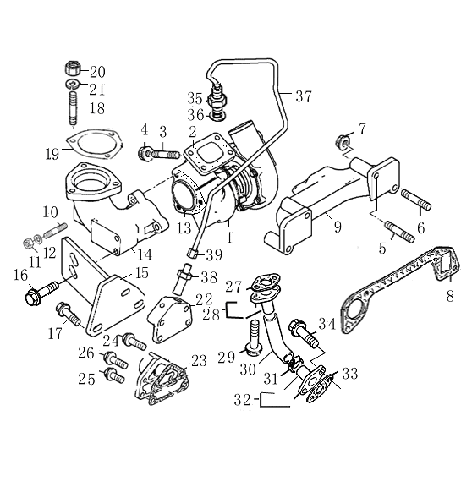
Induction & Exhaust System进、排气系统 SBHA
Item  图示号 | Family No.  组件号 | Part No.  零件号 | Part Name  零件名称 |  | Qty.  数量
1 | SB15C 0003 | T848010043 | 增压器 | Turbocharger | 1
2 | SB15C 0004 | TL681VF03 | 垫 | Joint | 1
3 | SB15C 0022 | TL254HF03A | 丝对 | Stud | 4
4 | SB15C 0031 | T2318A633 | 螺母 | Nut | 4
5 | SB16A 0001 | T2313M387A | 丝对 | Stud | 3
6 | SB16A 0002 | T2313M388A | 丝对 | Stud | 1
7 | SB16A 0004 | T2318A634 | 螺母 | Nut | 4
8 | SB16A 0013 | T3688C023 | 垫 | Joint | 2
9 | SB16A 0016 | T3778H201A | 排气管 | Exhaust Manifold | 1
10 | SB16D 0001 | T2313C078 | 双头螺柱 | Stud | 3
11 | SB16D 0004 | Q340B10F2 | 螺母 | Nut | 3
12 | SB16D 0005 | Q40310 | 弹簧垫圈 | Spring washer | 3
13 | SB16D 0010 | T64703009 | 密封垫片 | Joint | 1
14 | SB16D 0030 | T74706016 | 排气弯管 | Exhaust elbow | 1
15 | SB16D 0064 | T74703033 | 支架 | Bracket | 1
16 | SB16D 0132 | T2314J002 | 螺栓 | Screw | 2
17 | SB16D 0070 | T2314H004 | 螺栓 | Screw | 1
18 | SB16D 0210 | TT2313C078 | 双头螺柱 | Stud | 3
19 | SB16D 0211 | T3688C018 | 密封垫片 | Joint | 1
20 | SB16D 0212 | Q340B10 | 螺母 | Nut | 3
21 | SB16D 0213 | Q40310 | 弹簧垫圈 | Spring | 3
22 | SB20H 0001 | T748080002 | 接头 | Connection | 1
23 | SB20H 0002 | T3686T006 | 垫 | Joint | 1
24 | SB20H 0003 | T2314J037 | 螺栓 | Screw | 1
25 | SB20H 0004 | T2314J003 | 螺栓 | Screw | 2
26 | SB20H 0006 | T2314J033 | 螺栓 | Screw | 1
27 | SB20K 0100 | T3683D008 | 垫 | Joint | 1
28 | SB20K 0105 | T3571N007 | 油管（组件） | Pipe | 1

Induction & Exhaust System进、排气系统 SBHA

Induction & Exhaust System进、排气系统 SBHA
Item  图示号 | Family No.  组件号 | Part No.  零件号 | Part Name  零件名称 |  | Qty.  数量
29 | SB20K 0118 | T2314H003 | 螺栓 | Screw | 2
30 | SB20K 0136 | T3383A006 | 胶管 | Hose | 1
31 | SB20K 0139 | T2481877A | 喉箍 | Clipe | 1
32 | SB20K 0154 | T3571N008 | 油管 | Pipe | 1
33 | SB20K 0157 | T36832144 | 垫 | Joint | 1
34 | SB20K 0160 | T2314H003 | 螺栓 | Screw | 2
35 | SB20L 0270 | T0201502 | 接头 | Connection | 1
36 | SB20L 0273 | TL311KF01 | 垫圈 | Washer | 1
37 | SB20L 0305 | T4123T016 | 油管 | Pipe | 1
38 | SB20L 0343 | T33555138 | 接头 | Connection | 1
39 | SB20L 0369 | T2318A634 | 螺母 | Nut | 1

Low pressure fuel system 低压燃油系统 VBHA

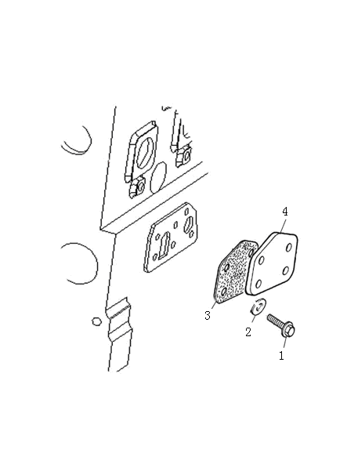
Low pressure fuel system 低压燃油系统 VBHA
Item  图示号 | Family No.  组件号 | Part No.  零件号 | Part Name  零件名称 |  | Qty.  数量
1 | VB17A 0001 | Q150B0820QS | 螺栓 | Screw | 4
2 | VB17A 0002 | Q40308 | 弹簧垫圈 | Spring washer | 4
3 | VB17A 0003 | T36856104 | 垫 | Joint | 1
4 | VB17A 0004 | T63207003A | 盖板 | Cover plate | 1

Low pressure fuel system 低压燃油系统 VBHA

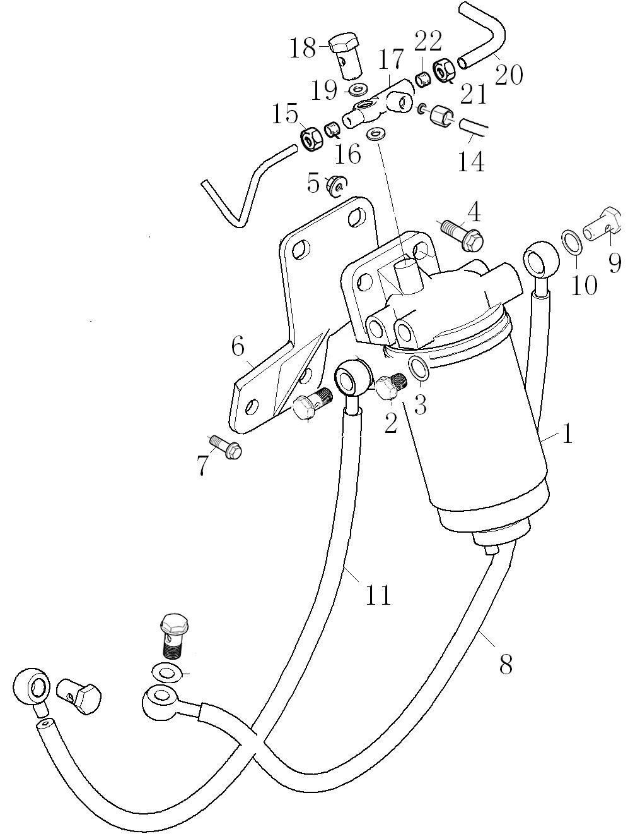
Low pressure fuel system 低压燃油系统 VBHA
Item  图示号 | Family No.  组件号 | Part No.  零件号 | Part Name  零件名称 |  | Qty.  数量
1 | VB17C 0001 | T64103002 | 滤清器 | Fuel filler | 1
2 | VB17C 0016 | T0650204 | 堵 | Plug | 1
3 | VB17C 0018 | T73274309 | 垫圈 | Washer | 1
4 | VB17C 0037 | T2314J004 | 螺栓 | Screw | 2
5 | VB17C 0070 | T2318A604 | 螺母 | Nut | 2
6 | VB17C 0221 | T750110048 | 支架 | Bracket | 1
7 | VB17C 0295 | T711050001 | 螺栓 | Screw | 1
8 | VB17K 0004 | T733150025 | 油管 | Oil pipe | 1
9 | VB17K 0086 | T711060022 | 过油螺栓 | Screw | 1
10 | VB17K 0087 | T73274309 | 密封垫圈 | Washer | 2
11 | VB17L 0001 | T733090046 | 油管 | Oil pipe | 1
14 | VB17M 0002 | T63302035 | 油管 | Oil pipe | 1
15 | VB17N 0118 | T33225412 | 螺母 | Nut | 1
16 | VB17N 0121 | T33811112 | 橄榄体 | Olive | 1
17 | VB17N 0148 | T73217019 | 接头 | Connection | 1
18 | VB17N 0151 | T0095344A | 过油螺栓 | Oil pass screw | 2
19 | VB17N 0154 | T73208144 | 垫圈 | Washer | 1
20 | VB17N 0282 | T73214200 | 回油管 | Oil return pipe | 1
21 | VB17N 0283 | T0576113 | 螺母 | Nut | 1
22 | VB17N 0286 | T0566004 | 橄榄体 | Olive | 1

Engine Lifting发动机提升 WDHA

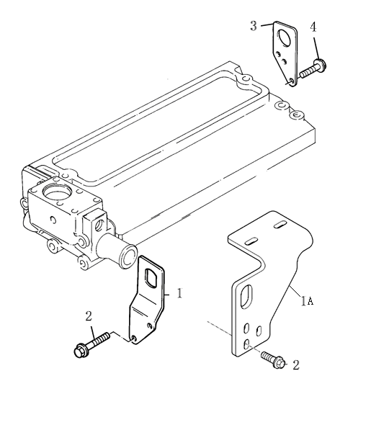

Engine Lifting发动机提升 WDHA
Item  图示号 | Family No.  组件号 | Part No.  零件号 | Part Name  零件名称 |  | Qty.  数量
1 | XB31D 0001 | T74707024 | 吊耳 | Lift bracket | 1
2 | XB31D 0007 | T2314J003 | 螺栓 | Screw | 3
3 | XB31E 0004 | T3654W003 | 吊耳 | Lift bracket | 1
4 | XB31E 0013 | T2314J003 | 螺栓 | Screw | 2

Throttle & Stop Controls油门及停车控制 ZAHA

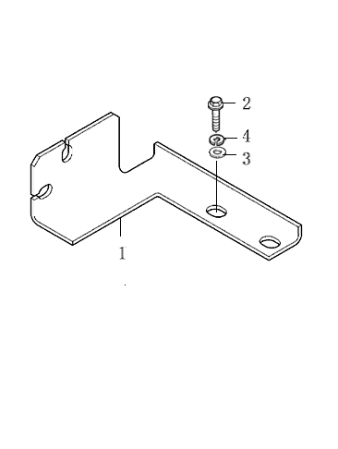

Throttle & Stop Controls油门及停车控制 ZAHA
Item  图示号 | Family No.  组件号 | Part No.  零件号 | Part Name  零件名称 |  | Qty.  数量
1 | ZA10A 0036 | T732110028 | 油门拉线支架 | Bracket | 1
2 | ZA10A 0037 | T2314J002 | 螺栓M10X20 | Screw | 2

Mountings支撑 ZCHA

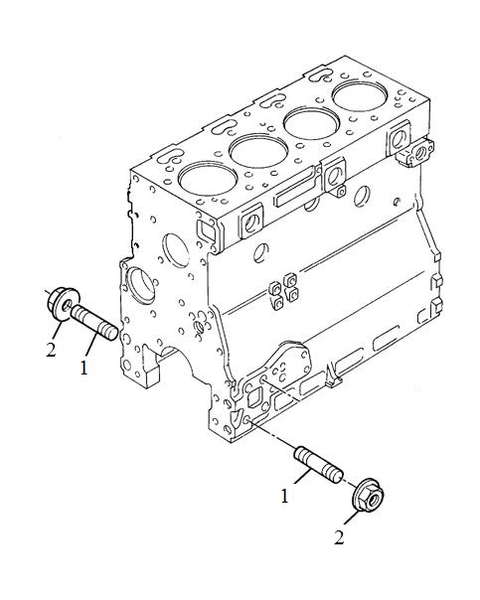

Mountings支撑 ZCHA
Item  图示号 | Family No.  组件号 | Part No.  零件号 | Part Name  零件名称 |  | Qty.  数量
1 | ZC31A 0092 | T2313M101 | 双头螺栓 | Stud | 8
2 | ZC31A 0118 | T2318A605 | 螺母 | Nut | 8

Lub.Oil Pressure Switch & Gauge润滑油压开关及油压表 ZJHA

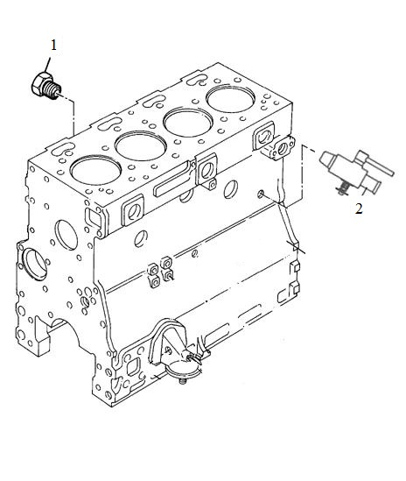

Lub.Oil Pressure Switch & Gauge润滑油压开关及油压表 ZJHA
Item  图示号 | Family No.  组件号 | Part No.  零件号 | Part Name  零件名称 |  | Qty.  数量
1 | ZM10A 0003 | T32161114M | 堵 | Plug | 1
2 | ZM10A 0002 | T62204003M | 放水阀 | Water Drain vavle | 1

Silencer消音器 ZUHA

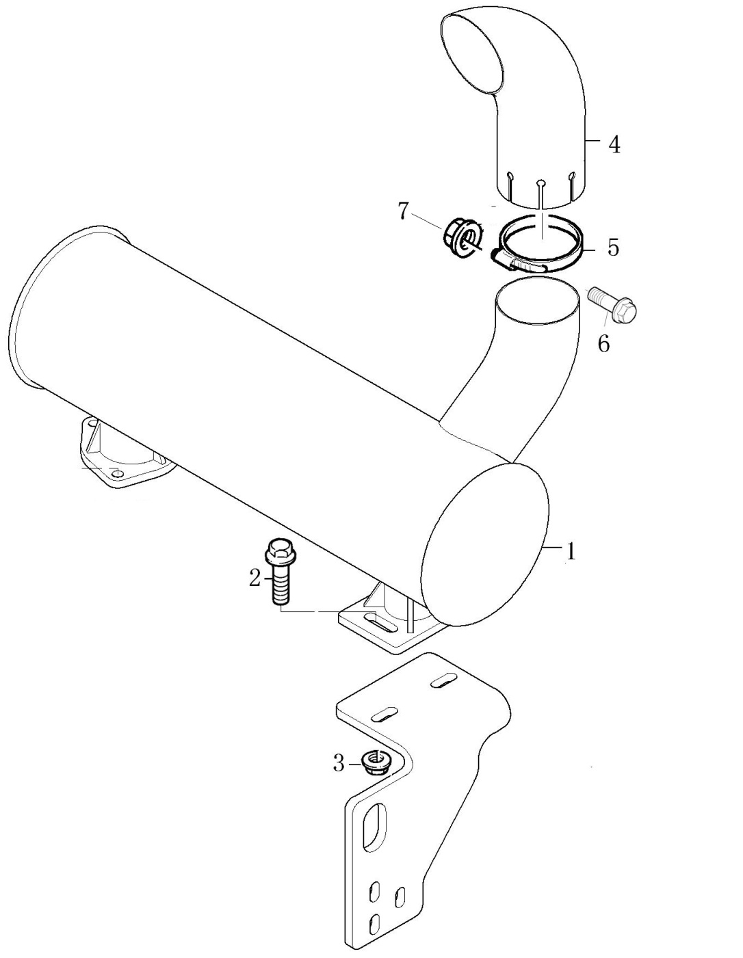
Silencer消音器 ZUHA
Item  图示号 | Family No.  组件号 | Part No.  零件号 | Part Name  零件名称 |  | Qty.  数量
1 | ZU16B 0001 | T747180016 | 消音器 | Silencer | 1
2 | ZU16B 0002 | T2314J005 | 螺栓 | Screw | 2
3 | ZU16B 0003 | Q340B10 | 螺母 | Nut | 2
4 | ZU16B 0007 | T747130051 | 消音器尾管 | Pipe | 1
5 | ZU16B 0008 | T64701126 | 卡子 | Clip | 1
6 | ZU16B 0009 | T2314J006 | 螺栓 | Screw | 1
7 | ZU16B 0010 | T2318A604 | 螺母 | Nut | 1

Joints & Gaskets-Top Service Kit垫及垫片（顶部维修组件） SACA

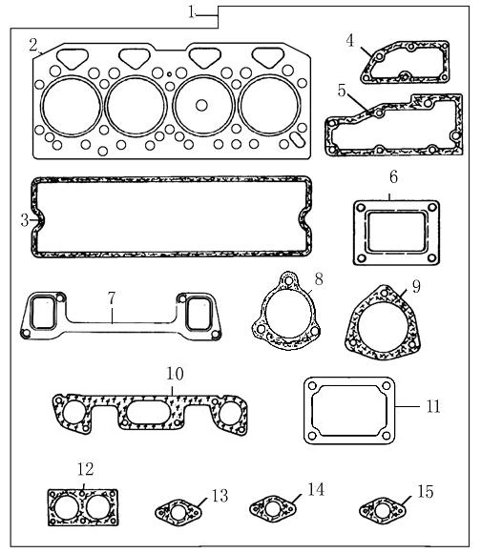
Joints & Gaskets-Top Service Kit垫及垫片（顶部维修组件） SACA
Item  图示号 | Family No.  组件号 | Part No.  零件号 | Part Name  零件名称 |  | Qty.  数量
1 | TU5LT0178 |  | 顶部垫片 | Joint-Top Kit | 1
2 |  | T3681E033D | 缸盖垫 | Gasket | 1
3 |  | T3681A021A | 缸盖罩垫 | Cyl. Head Cover Joint | 1
4 |  | T3685R005 | 气缸盖后盖板垫 | Cyl. Head Rear Cover Plate | 1
5 |  | T3685F005 | 节温器壳体垫 | Rind Joint | 1
6 |  | TL681VF03 | 增压器-排气管 | Turbocharger Joint | 1
7 |  | T3688C023 | 排气歧管垫 | Exhaust manifold Joint | 1
8 |  | T64703009 | 排气弯管-增压器 | Exhaust elbow Joint | 1
9 |  | T3688C018 | 排气弯管-消音器 | Exhaust elbow Joint | 1
10 |  | T3688C024 | 进气歧管垫 | Induction manifold Joint | 1
11 |  | T3684N009 | 进气弯管垫 | Induction elbow Joint | 1
12 |  | T3684A004 | 出水口垫 | Water Outlet Joint | 1
13 |  | T3683D008 | 增压器回油管垫 | Joint | 1
14 |  | T36832144 | 增压器回油管垫 | Joint | 1
15 |  | T3683N004 | 过水三通垫 | Water Outlet Joint | 1

Joints & Gaskets-Bottom Service Kit垫及垫片（底部维修组件） SACA

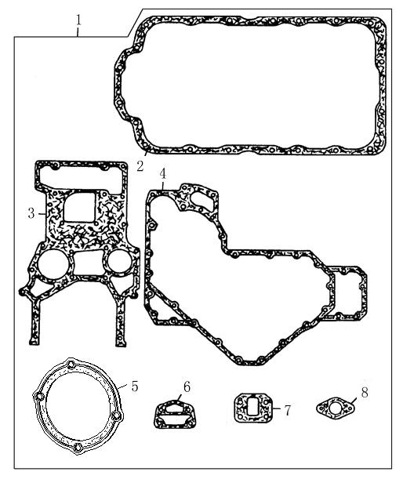
Joints & Gaskets-Bottom Service垫及垫片（底部维修组件） SACA
Item  图示号 | Family No.  组件号 | Part No.  零件号 | Part Name  零件名称 |  | Qty.  数量
1 | TU5LB0052 |  | 底部垫片 | Joint-Bottom Kit
2 |  | T36815736 | 油底壳垫 | Sump Joint | 1
3 |  | T3681P009 | 正时室垫 | Timing Case Joint | 1
4 |  | T3681P034 | 正时室盖垫 | Front Cover Joint | 1
5 |  | T3682H003 | 检查盖垫 | Inspection Cover Joint | 1
6 |  | T3686T006 | 机油滤座垫 | Joint | 1
7 |  | T36856104 | 输油泵垫 | Lift Pump Joint | 1
8 |  | T36832137 | 机油管垫 | Lub.Oil Pipe Joint | 1

A set with four segments四配套

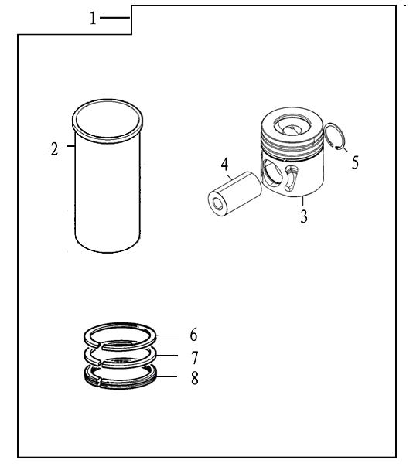
A set with four segments四配套
Item  图示号 | Family No.  组件号 | Part No.  零件号 | Part Name  零件名称 |  | Qty.  数量
1 |  |  | 四配套 | A set with four segments | 1
2 |  | T721020012 | 缸套 | Liner | 4
3 |  | T3135J186A | 活塞 | PISTON | 4
4 |  | T3313T005 | 活塞销 | Piston Pin | 4
5 |  | T2721332 | 卡簧 | CIRCLIP | 8
6 |  | T3136J051 | 气环 | AIR RING | 4
7 |  | T3136X021 | 气环 | AIR RING | 4
8 |  | T3137N021 | 油环 | OIL RING | 4

